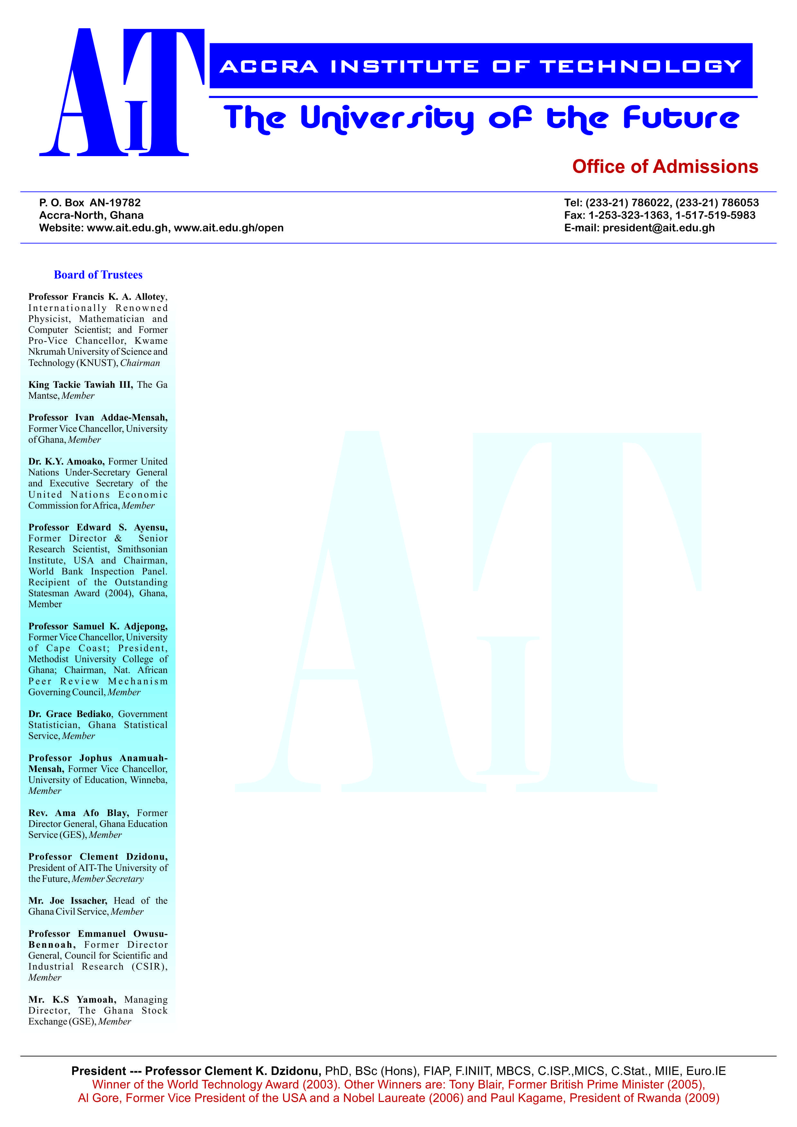

**END OF SEMESTER EXAMINATIONS**

2ND SEMESTER 2022/2023 ACADEMIC YEAR

DATE: JULY 2023

**COURSE CODE: MATH302**

**COURSE TITLE: OPERATION RESEARCH**

**LECTURER’S NAME: MAXWELL SUOBOGBIREE**

**DURATION: 3 HOURS**

**APPENDICES**

|  |  |  |
| --- | --- | --- |
|  | **COURSE OUTLINE**  **(MAIN TOPICS)** | **QUESTION NO.** |
| **MajorTopic-1** | Linear Programming (LP) | Q1  Q2  Q3 |
| **MajorTopic-2** | Markov Chain | Q4 |
| **MajorTopic-3** | Network Theory | Q5 |
| **MajorTopic-4** | LP: Graphical Analysis | Q6a |
| **MajorTopic-5** | Markov chain | Q6b  Q6c  Q6d |
| **MajorTopic-6** |  |  |
| **MajorTopic-7** | Duality Theory | Q7a |
| **MajorTopic-8** | Queueing Theory | Q7b  Q7c  Q7d |
| **MajorTopic-9** | Game Theory: Pure strategy | Q8a |
| **MajorTopic-10** | Game Theory: Dominance property | Q8b |
| **MajorTopic-11** | Network Theory: Minimum spanning tree | Q8c |
| **MajorTopic-12** | Network Theory: Maximum flow | Q8d |
| **MajorTopic-13** | LP: Model Formulation | Q9a |
| **MajorTopic-14** | LP: Computer Solution & Sensitivity Analysis | Q9b  Q9c  Q9d |
| **MajorTopic-15** | Transportation model | Q10a  Q10b  Q10c  Q10d |
| **………….** |  |  |

**PART A (UNDERSTANDING)**

**INSTRUCTIONS: Part A contains FIVE questions. Answer ALL questions.**

**Questions**

1. Explain what is meant by feasible solution area? And what constitutes the feasible solution area on the graph of a linear programming model?

|  |  |  |
| --- | --- | --- |
| **Major Topic**  **Linear Programming: Feasible Solution Area** | **Blooms Designation**  UN | **Score**  **5** |

1. What does sliding an objective function line toward the origin and away from the origin represent in maximization and minimization LP?

|  |  |  |
| --- | --- | --- |
| **Major Topic**  **Linear Programming: Objective function line** | **Blooms Designation**  UN | **Score**  **5** |

3. In one sentence carefully distinguish between slack and surplus

|  |  |  |
| --- | --- | --- |
| **Major Topic**  **Linear Programming: Slack & surplus** | **Blooms Designation**  UN | **Score**  **5** |

1. The States of a Markov chain can be classified based on the transition probability. State and Explain at least THREE (3) classified states of the Markov chain.

|  |  |  |
| --- | --- | --- |
| **Major Topic**  **LP: Graphical analysis** | **Blooms Designation**  UN | **Score**  **5** |

**5.** With the help of diagram, distinguish between a directed network and

undirected network.

|  |  |  |
| --- | --- | --- |
| **Major Topic**  **Network Theory** | **Blooms Designation**  UN | **Score.**  **5** |

**TOTAL SCORE: 25 MARKS**

**PART B [APPLICATION AND ANALYSIS]**

**INSTRUCTIONS: Part B contains THREE questions. Attempt any TWO questions.**

|  |
| --- |
|  |

**Question 6.**

A furniture company process tables and chairs. Each table require 4 hours of carpentry work and 2 hours of painting work while each chair requires 3 hours of carpentry work and 1 hour of painting work. During the current production period, 240 hours of carpentry time are available and 100 hours of painting time are available. Each table sold yields a profit of GH¢ 70 while each chair sold yields a profit of GH¢ 50.

1. Formulate a linear programming model for this problem and solve the model by using graphical method indicating the optimal solution and objective function value.

|  |  |  |
| --- | --- | --- |
| **Major Topic**  LP: Graphical analysis | **Blooms Designation**  AP | **Score**  **7** |

1. There are three categories of income tax filers in Ghana: those who never evade taxes, those who sometimes do it, and those who always do it. An examination of audited tax returns from 1 year to the next shows that of those who did not evade taxes last year, 95% continue to be in the same category this year, 4% move to the “sometimes” category, and the remainder move to the “always” category. For those who sometimes evade taxes, 6% move to “never,” 90% stay the same, and 4% move to “always.” As for the “always” evaders, the respective percentages are 0%, 10%, and 90%. Express the problem as a Markov chain.

|  |  |  |
| --- | --- | --- |
| **Major Topic**  **Markov Chain** | **Blooms Designation**  AP | **Score**  **6** |

1. In the long run, what would be the percentages of “never,” “sometimes,” and “always” tax categories? (ie steady-state)

|  |  |  |
| --- | --- | --- |
| **Major Topic**  Markov Chain | **Blooms Designation**  AN | **Score**  **7** |

1. Considering the Markov chain express in (b), draw the transition matrix and evaluate given that



|  |  |  |
| --- | --- | --- |
| **Major Topic**  **Markov Chain** | **Blooms Designation**  AN | **Score**  **5** |

**TOTAL SCORE: 25 MARK**

**Question 7**

TOYOTA Ghana Ltd. assembles five types of cars—collora, berta, matrix, auris and virtz—using three operations. Available assembly times for the three operations are 300, 400, and 1000 minutes per day, respectively, and the revenues per car collora, Berta, matrix, auris and virtz are $40, $30, $20, $10 and $10, respectively. Letting x1, x2, x3, x4 and x5 represent the daily number of units assembled of collora, berta, matrix, auris and virtz, the associated primal LP model is given as follows:



1. write the dual of the primal problem.

|  |  |  |
| --- | --- | --- |
| **Major Topic**  **Duality Theory** | **Blooms Designation**  AP | **Score**  **5** |

1. motorist travelling to the Eastern Region Mountains on the Aburi road have to stop at the Ayi Mensah tollbooth to pay their tolls. Motorist arrive at the tollbooth at a rate of 25 every 60 minutes. The single tollbooth server can serve, on average 55 motorist every 2 hours. What is the average time (in minutes) a motorist waits in the queue to be served? And the average number of motorists waiting, correct to the nearest whole number.

|  |  |  |
| --- | --- | --- |
| **Major Topic**  Queueing Theory | **Blooms Designation**  AN | **Score**  **6** |

1. The tollbooth supervisor perceives that the waiting time computed in (b) above is not acceptable and it wishes to reduce it. He is therefore thinking an option of adding an extra assistant to help improve the service rate to 8 motorist every 15 minutes. The assistant will be paid a monthly salary of GHs 800. If management choose this option, they will avoid lost sales of GHs 1,200.00 per month for every minute that average waiting time is reduced. What will be your advice for management on this option?

|  |  |  |
| --- | --- | --- |
| **Major Topic**  Queueing Theory | **Blooms Designation**  AP | **Score**  **7** |

1. The supervisor is also considering a second option which is that management can add a toll-operated machine which will cost GHs 3000 and this amount is a free gift from the DCE of the area. This option will alter the arrival rate to 3 motorists every 10 minutes. However, management will have to pay the operator who will man the toll-operated machine a monthly salary of GHs 550. If management adopt this second option, they will avoid a lost sales of 1,200.00 per month for every minute that average waiting time is reduced. Comparing this second option to the first option in (c), which option will you advise management to adopt as the best and why?

|  |  |  |
| --- | --- | --- |
| **Major Topic**  **Queueing Theory** | **Blooms Designation**  AN | **Score**  **7** |

**TOTAL SCORE: 25 MARS**

**Question 8**

Two companies share the bulk of the market for a particular kind of product. Each is now planning its new marketing plans for the next year in an attempt to wrest some sales away from the other company. (The total sales for the product are relatively fixed, so one company can increase its sales only by winning them away from the other.) Each company is considering three possibilities: (1) better packaging of the product, (2) increased advertising, and (3) a slight reduction in price. The costs of the three alternatives are quite comparable and sufficiently large that each company will select just one. The estimated effect of each combination of alternatives on the increased percentage of the sales for company 1 is as follows:

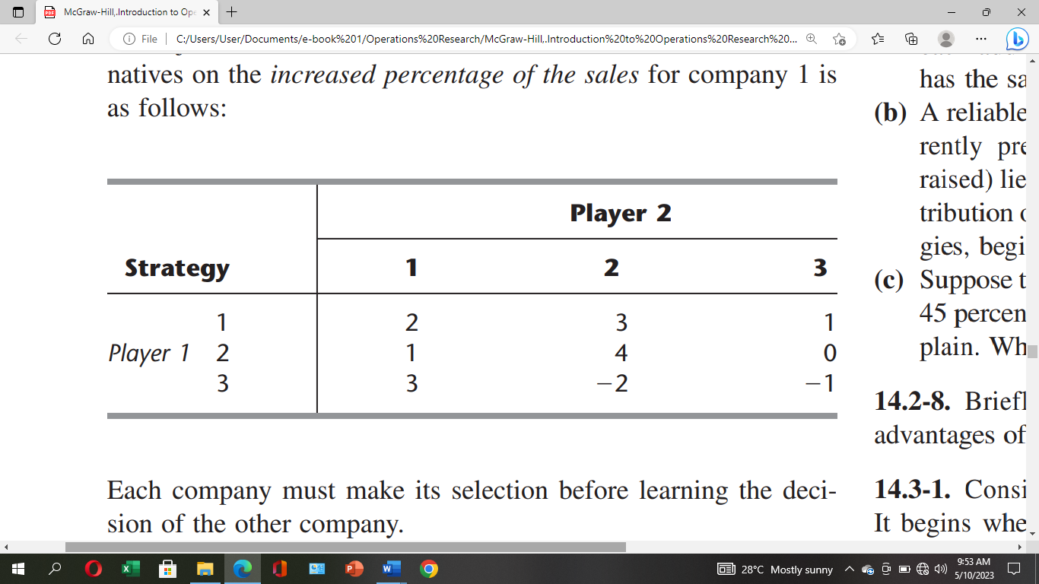

Each company must make its selection before learning the decision of the other company

1. Without eliminating dominated strategies, use the minimax (or maximin) criterion to determine the best strategy for each company.

|  |  |  |
| --- | --- | --- |
| **Major Topic**  **Game Theory: Pure strategy** | **Blooms Designation**  AP | **Score**  **5** |

1. Now identify and eliminate dominated strategies as far as possible. Make a list of the dominated strategies, showing the order in which, you were able to eliminate them. Then show the resulting reduced payoff table with no remaining dominated strategies.

|  |  |  |
| --- | --- | --- |
| **Major Topic**  Game Theory: Dominance property | **Blooms Designation**  AN | **Score**  **7** |

1. AIT wants to develop an area network that will connect its server at its computer and satellite center with the main campus buildings to improve Internet service. The cable will be laid primarily through existing electrical tunnels, although some cable will have to be buried underground. The following network in fig. 1 shows the possible cable connections between the computer center at node 1 and the various buildings, with the distances, in feet, along the branches. Determine a minimal spanning tree network that will connect all the buildings and indicate the total amount of cable that will be needed to do so.

Fig.1

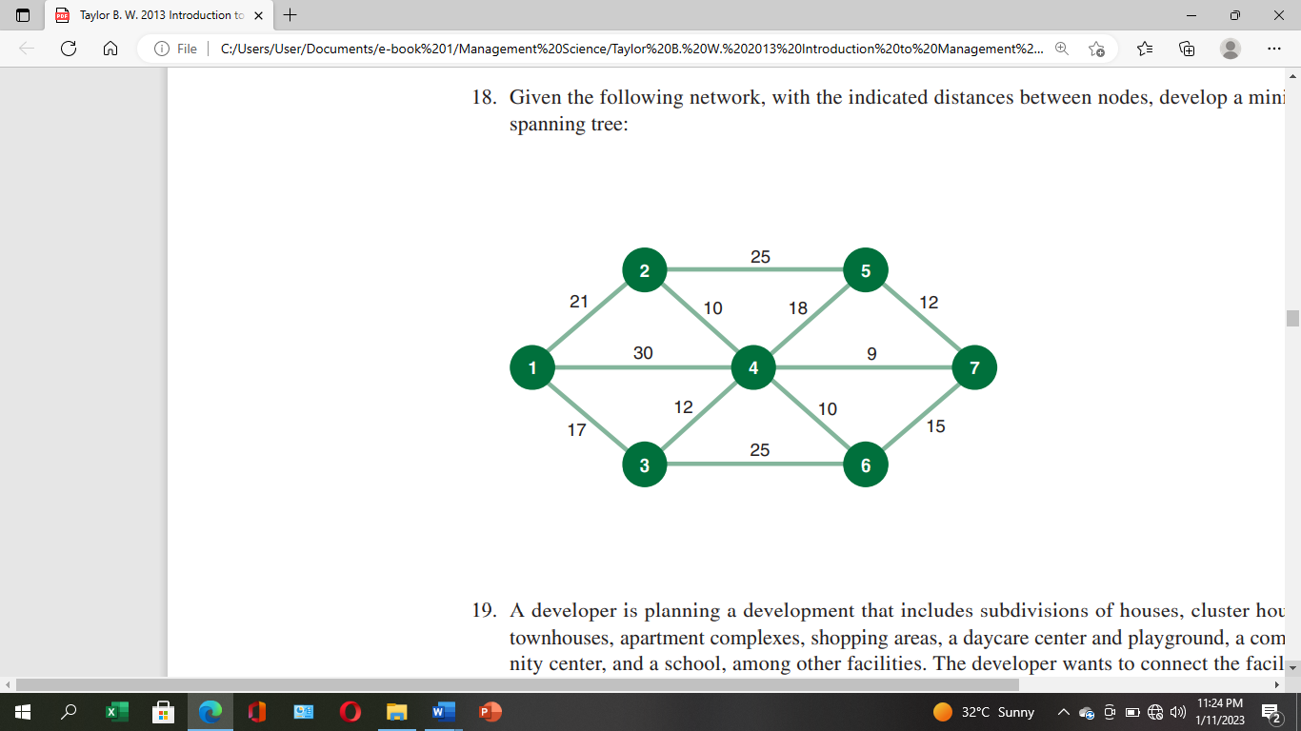

|  |  |  |
| --- | --- | --- |
| **Major Topic**  Network Theory: Minimum spanning tree | **Blooms Designation**  AP | **Score**  **6** |

1. Given the following network, with the indicated flow capacities along each branch, analyze the maximum flow from source node 1 to destination node 6 and determine the flow along each branch.

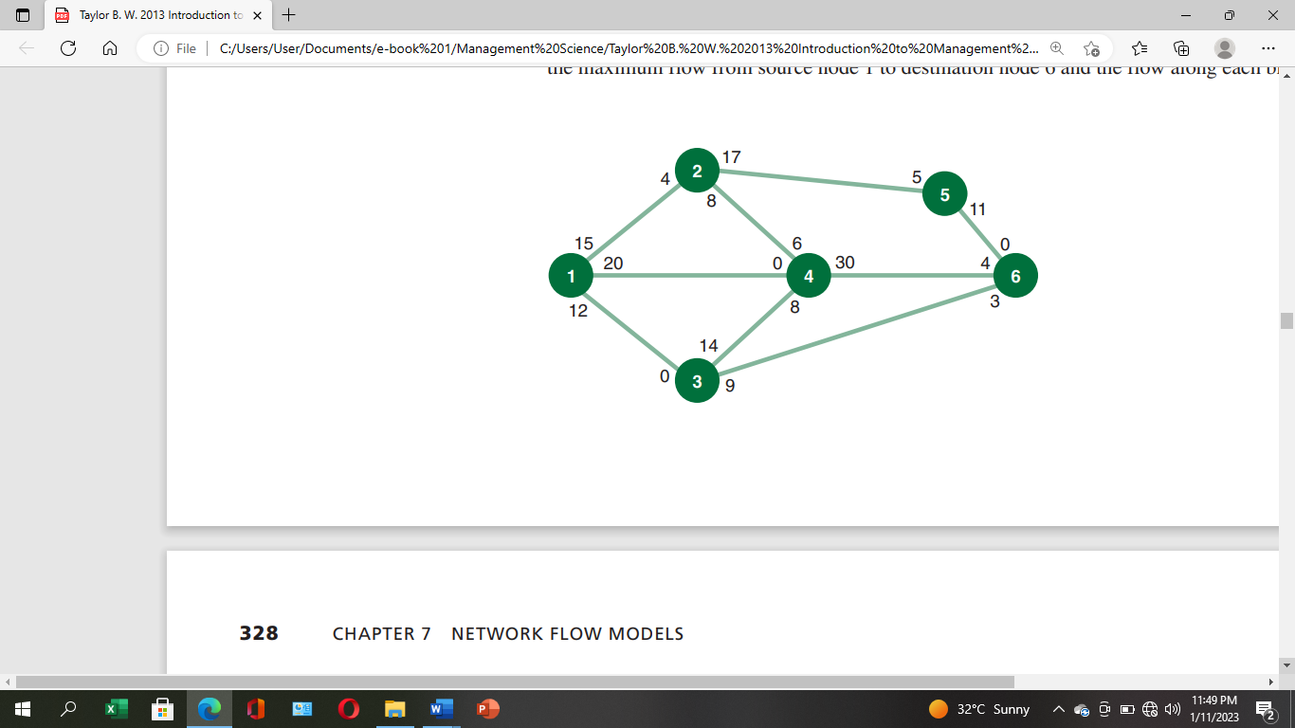

|  |  |  |
| --- | --- | --- |
| **Major Topic**  **Network Maximum Flow** | **Blooms Designation**  AN | **Score**  **7** |

**TOTAL SCORE: 25 MARK**

**PART C [EVALUATING AND CREATING]**

**INSTRUCTIONS: Part C contains TWO questions. Answer ONE question.**

|  |
| --- |
|  |

**Question 9**

Fan Milk Ghana Ltd. Manager wants to determine how many sachets of FanChoco, Fanice and FanYogo to produce to maximize weekly profits. Fan Choco sells for GH¢101 a sachet but generates a unit-level cost of GH¢91. Fanice sells for GH¢67 a sachet but incurs a unit-level cost GH¢57 and FanYoco sells for GH¢97.50 per sachet but incurs a unit-level cost of GH¢87.50. The firm requires 1 gallon of milk, 5 gallons of milk and 3 gallons of milk to produce a sachet of Fan Choco, Fan ice and FanYogo respectively. Corresponding values for hours of labour are 2 hours, 3.5 hours and 4 hours. Additionally, only 2oz of sugar are needed to produce Fan Choco and 4oz of sugar are needed to produce Fan ice. No ounce of sugar is required to produce FanYogo. Each week, there are 300 gallons of milk available, 200 hours of labour available and 400 ounces of sugar available. Moreover, there is a demand for sachets of FanYogo that is not below 10 sachets each week.

1. Formulate a linear programming model for this problem and convert the model formulated into a standard form

|  |  |  |
| --- | --- | --- |
| **Major Topic**  LP: Model Formulation | **Blooms Designation**  **CR** | **Score**  **7** |

The model was solved using excel solver and part of the results is provided in table 9(i)

|  |  |  |  |  |  |  |  |
| --- | --- | --- | --- | --- | --- | --- | --- |
| **Microsoft Excel 16.0 Sensitivity Report** | | | | |  |  |  |
| **Worksheet: [Book1] Sheet1** | | |  |  |  |  |  |
| **Report Created: 5/12/2023 11:36:16 PM** | | | | |  |  |  |
|  |  |  |  |  |  |  |  |
|  |  |  |  |  |  |  |  |
| **Table 9(i)** | | |  |  |  |  |  |
|  |  |  | **Final** | **Reduced** | **Objective** | **Allowable** | **Allowable** |
|  | **Cell** | **Name** | **Value** | **Cost** | **Coefficient** | **Increase** | **Decrease** |
|  | $B$9 | FanChoco | 80 | 0 | 10 | 1E+30 | 4.285714286 |
|  | $B$10 | Fanice | 0 | -7.5 | 10 | 7.5 | 1E+30 |
|  | $B$11 | FanYogo | 10 | 0 | 10 | 10 | 1E+30 |
|  |  |  |  |  |  |  |  |
| Constraints | | |  |  |  |  |  |
|  |  |  | **Final** | **Shadow** | **Constraint** | **Allowable** | **Allowable** |
|  | **Cell** | **Name** | **Value** | **Price** | **R.H. Side** | **Increase** | **Decrease** |
|  | $F$4 | Constraint 1 Usage | 110 | 0 | 300 | 1E+30 | 190 |
|  | $F$5 | Constraint 2 Usage | 200 | 5 | 200 | 240 | 160 |
|  | $F$6 | Constraint 3 Usage | 160 | 0 | 400 | 1E+30 | 240 |
|  | $F$7 | Constraint 4 Usage | 10 | -10 | 10 | 40 | 10 |

1. What will be the total weekly profit for Fan Milk Ghana Ltd? Also, indicate which resource constraint(s) is/are binding and give two (2) reasons for your answer.

|  |  |  |
| --- | --- | --- |
| **Major Topic**  Sensitivity analysis | **Blooms Designation**  **EV** | **Score**  **7** |

1. What is the minimum profit contribution for Fanice so that it will attain a positive value in the optimal solution? And if the company manager could obtain extra 100 gallons of milk or an extra 10 labours, but not both, which should he choose?

|  |  |  |
| --- | --- | --- |
| **Major Topic**  Sensitivity analysis | **Blooms Designation**  **CR** | **Score**  **6** |

1. Suppose that the objective function coefficient for FanYogo increases by GH¢8. What impact will this have on the current values of the optimal solution? How could that affect profit?

|  |  |  |
| --- | --- | --- |
| **Major Topic**  Sensitivity analysis | **Blooms Designation**  **EV** | **Score**  **5** |

**TOTAL SCORE: 25 MARKS**

**Question 10**

Compu Ghana sells personal computers to universities and ships them from three distribution warehouses. The firm is able to supply the following numbers of computers to the universities by the beginning of the academic year. Four universities have ordered computers that must be delivered and installed by the beginning of the academic year. The number of computers that can be supplied by the firm, the shipping and installation costs per computer from each distributor to each university are as follows:

|  |  |  |  |  |  |
| --- | --- | --- | --- | --- | --- |
| **From/To** | **KNUST** | **University of Ghana** | **Cape coast university** | **AIT** | **supply** |
| **Accra** | Ghs 22 | 17 | 30 | 14 | **420** |
| **Kumasi** | 15 | 35 | 20 | 25 | **610** |
| **Takoradi** | 28 | 21 | 16 | 18 | **340** |
| **Demand** | **560** | **280** | **410** | **340** |  |

Using the above information, answer the following questions:

1. Provide a fully labeled network representation for the problem

|  |  |  |
| --- | --- | --- |
| **Major Topic**  **Transportation Model** | **Blooms Designation**  **CR** | **Score**  **5** |

1. Establish the decision variables and formulate the linear programming model to determine the optimal transportation from the warehouses to the universities to minimize total transport cost

|  |  |  |
| --- | --- | --- |
| **Major Topic**  **Transportation Model** | **Blooms Designation**  **EV** | **Score**  **6** |

1. Using the North West Corner Rule and completing the transportation tableau, how many number of computers must be moved from each warehouse to each university in order to minimize the total transportation distance? Find the total transportation distance.

|  |  |  |
| --- | --- | --- |
| **Major Topic**  **Transportation Model: NWC** | **Blooms Designation**  **CR** | **Score**  **7** |

1. Using the least cost method, find the minimum total cost and compare the results with that of the North West Corner Rule. What can you say?

|  |  |  |
| --- | --- | --- |
| **Major Topic**  **Transportation Model: NWC/MC** | **Blooms Designation**  **EV** | **Score**  **7** |

**TOTAL SCORE: 25 MARKS**

SOME USEFUL FORMULAE

1. = (1− )











**END OF QUESTION PAPER**