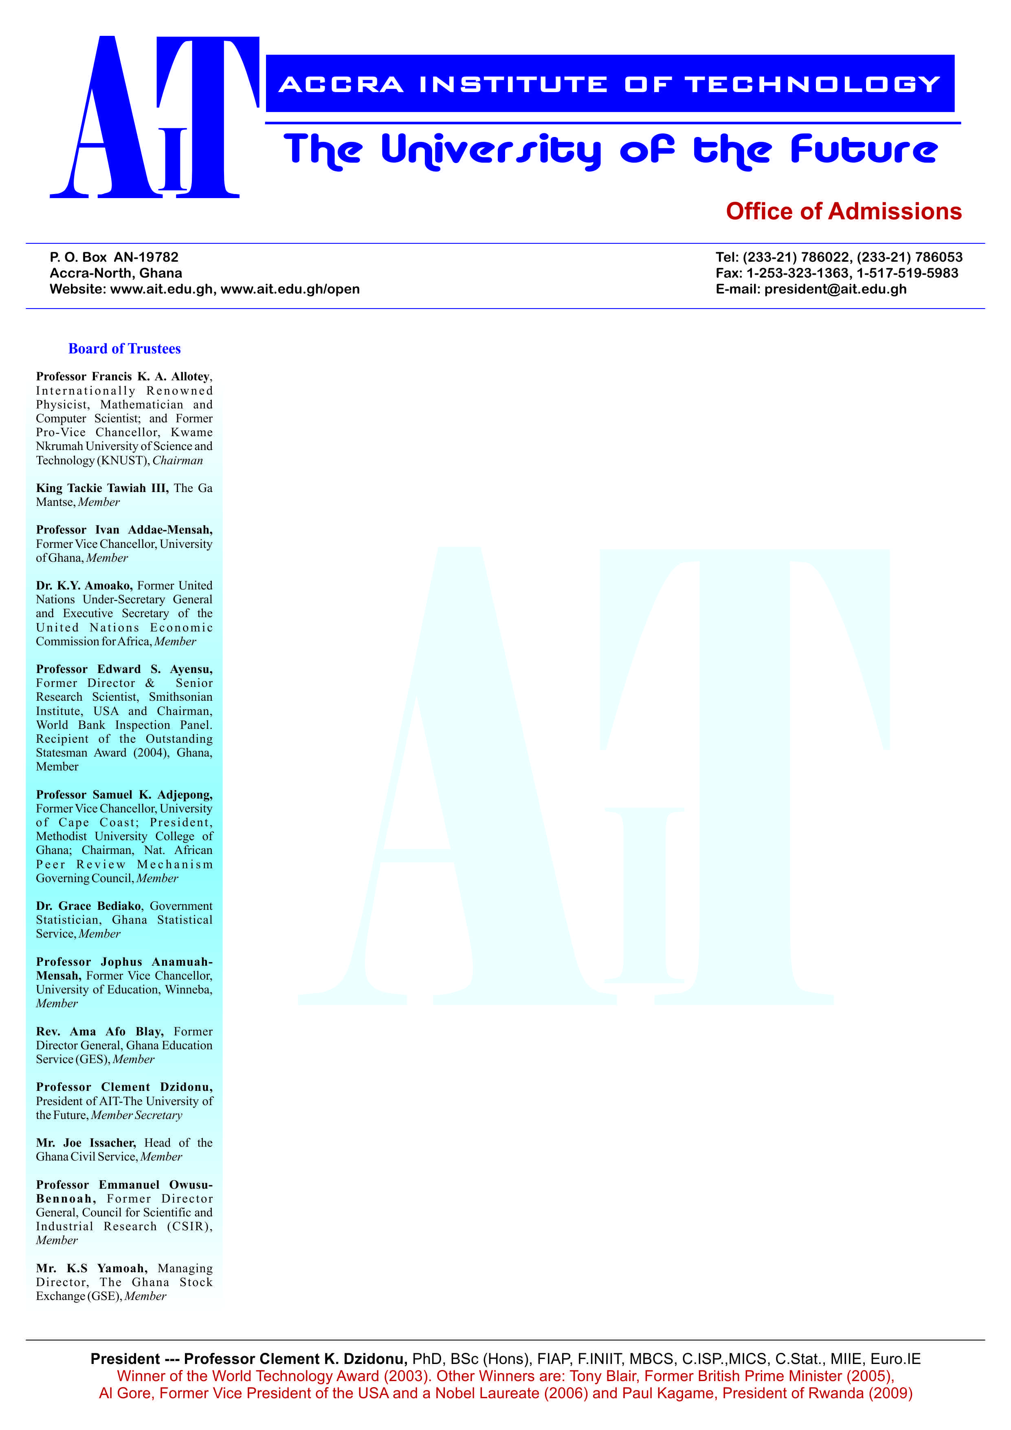

**END OF SEMESTER EXAMINATIONS**

2ND SEMESTER 2022/2023 ACADEMIC YEAR

DATE: JULY 2023

**COURSE CODE: EEE 306**

**COURSE TITLE: MICROPROCESSOR I&II**

**LECTURER’S NAME: HARRY WARDEN**

**DURATION: 3 HOURS**

**APPENDICES**

|  |  |  |
| --- | --- | --- |
|  | **COURSE OUTLINE**  **(MAIN TOPICS)** | **QUESTION NO.** |
| **MajorTopic-1** | Application of Microprocessors | 1 |
| **MajorTopic-2** | General Concept of Microprocessors | 2 |
| **MajorTopic-3** | Computer Software | 3 |
| **MajorTopic-4** | Evolution of Intel Microprocessors | 4 |
| **MajorTopic-5** | RISC and CISC Architecture | 5 |
| **MajorTopic-6** | Microprocessor Architecture Types | 6a, b, c, d |
| **MajorTopic-7** | General Concept of Microprocessors | 7a, b, c, d |
| **MajorTopic-8** | 8086 Microprocessors | 8a, b, c, d |
| **MajorTopic-9** | Assembly language Statement/Instruction | 9a,b.c.d & 10a,b,c,d |

**PART A (UNDERSTANDING)**

**INSTRUCTIONS: Part A contains FIVE questions. Answer ALL questions.**

**Questions**

1. Outline ten (10) practical applications of microprocesses.

|  |  |  |
| --- | --- | --- |
| **Major Topic**  Application of Microprocesses | **Blooms Designation**  UN | **Score**  **5** |

2. In your opinion, why is it important for every engineer to learn how to use or have knowledge about microprocesses.

|  |  |  |
| --- | --- | --- |
| **Major Topic**  General Concept of Microprocessors | Blooms Designation  UN | **Score**  **5** |

3. Differentiate between Source Code and Object Code in Computer Software.

|  |  |  |
| --- | --- | --- |
| **Major Topic**  Computer Software | **Blooms Designation**  UN | **Score**  **5** |

4. List ten (10) Intel microprocesses according to their Names, Bit size and Year of release.

|  |  |  |
| --- | --- | --- |
| **Major Topic**  **Evolution of Intel Microprocessors** | **Blooms Designation**  UN | **Score**  **5** |

**5**. Differentiate between RISC (reduced instruction set computer) and CISC (complex instruction set computer).

|  |  |  |
| --- | --- | --- |
| **Major Topic**  RISC And CISC Architecture | **Blooms Designation**  UN | **Score.**  **5** |

**TOTAL SCORE: 25 MARKS**

**PART B[APPLICATION AND ANALYSIS]**

**INSTRUCTIONS: Part B contains THREE questions. Attempt any TWO questions.**

|  |
| --- |
|  |

**Question 6.**

**C**

**C**

**B**

**A**

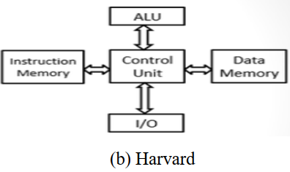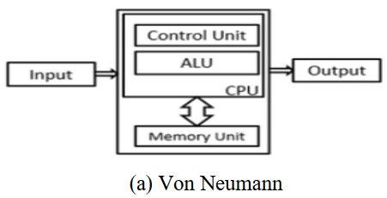

1. Identify Figure A and B indicated above.

|  |  |  |
| --- | --- | --- |
| **Major Topic**  Microprocessor Architecture Types | **Blooms Designation**  AP/AN | **Score**  **7** |

1. Differentiate between Figure A and B.

|  |  |  |
| --- | --- | --- |
| **Major Topic**  Microprocessor Architecture Types | **Blooms Designation**  AP/AN | **Score**  **7** |

1. Identify the part labelled C.

|  |  |  |
| --- | --- | --- |
| **Major Topic**  Microprocessor Architecture Types | **Blooms Designation**  AP/AN | **Score**  **5** |

1. Explain the role/function of the part labelled C.

|  |  |  |
| --- | --- | --- |
| **Major Topic**  Microprocessor Architecture Types | **Blooms Designation**  AP/AN | **Score**  **6** |

**TOTAL SCORE: 25 MARKS**

**Question 7**

A factory in the production of liquid detergents needs a device to automatically control the agitator of one of its remote mixing tanks.

1. As electronics engineer of that factory, what device would you recommend.

|  |  |  |
| --- | --- | --- |
| **Major Topic**  General Concept of Microprocessor | **Blooms Designation**  AP | **Score**  **7** |

1. Give reasons for your choice.

|  |  |  |
| --- | --- | --- |
| **Major Topic**  General Concept of Microprocessor | **Blooms Designation**  AN | **Score**  **7** |

1. Name the components that make up the device above.

|  |  |  |
| --- | --- | --- |
| **Major Topic**  General Concept of Microprocessor | **Blooms Designation**  AP | **Score**  **5** |

1. Explain the functions of each component named in question (c) above.

|  |  |  |
| --- | --- | --- |
| **Major Topic**  General Concept of Microprocessor | **Blooms Designation**  AN | **Score**  **6** |

**TOTAL SCORE: 25 MARKS**

**Question 8**

Figure A

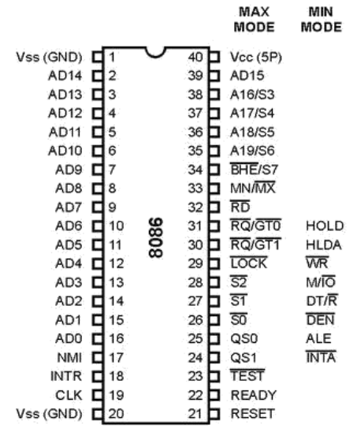

1. Identify Figure A above.

|  |  |  |
| --- | --- | --- |
| **Major Topic**  8086 Microprocessor | **Blooms Designation**  AP | **Score**  **7** |

1. Enumerate the functions of the following pins: A19/S6, A18/S5, A17/S4, A16/S3.

|  |  |  |
| --- | --- | --- |
| **Major Topic**  8086 Microprocessor | **Blooms Designation**  AN | **Score**  **7** |

1. Which pin is used to indicate the transfer of data over the higher order (D15-D8) data bus.

|  |  |  |
| --- | --- | --- |
| **Major Topic**  8086 Microprocessor | **Blooms Designation**  AP | **Score**  **6** |

1. What are these pins:AD15-AD0.

|  |  |  |
| --- | --- | --- |
| **Major Topic**  8086 Microprocessor | **Blooms Designation**  AN | **Score**  **5** |

**TOTAL SCORE: 25 MARKS**

**PART C [EVALUATING AND CREATING]**

**INSTRUCTIONS: Part C contains TWO questions. Answer ONE question.**

|  |
| --- |
|  |

**Question 9**

**INC COUNT;**

**MOV TOTAL, 28;**

**ADD AH, BH;**

**AND FASK, 120;**

**ADD SCORE, 5;**

**MOV AL, 5;**

1. Write the meaning of the instruction or comment on the program instruction

MOV TOTAL, 28;

|  |  |  |
| --- | --- | --- |
| **Major Topic**  Assembly language Statement | **Blooms Designation**  **CR/EV** | **Score**  **7** |

1. Write the meaning of the instruction or comment on the program instruction.

ADD AH, BH;

|  |  |  |
| --- | --- | --- |
| **Major Topic**  Assembly language Statement | **Blooms Designation**  **CR/EV** | **Score**  **7** |

1. Write the meaning of the instruction or comment on the program instruction.

AND FASK, 120;

|  |  |  |
| --- | --- | --- |
| **Major Topic**  Assembly language Statement | **Blooms Designation**  **CR/EV** | **Score**  **6** |

1. Write the meaning of the instruction or comment on the program instruction.

INC COUNT;

|  |  |  |
| --- | --- | --- |
| **Major Topic**  Assembly language Statement | **Blooms Designation**  **CR/EV** | **Score**  **5** |

**TOTAL SCORE: 25 MARKS**

**Question 10**

1. Write an assembly language program instruction to compare registers AL and BL.

|  |  |  |
| --- | --- | --- |
| **Major Topic**  Assembly language Statement | **Blooms Designation**  **CR/EV** | **Score**  **7** |

1. Write an assembly language program instruction to move count in AX.

|  |  |  |
| --- | --- | --- |
| **Major Topic**  Assembly language Statement | **Blooms Designation**  **CR/EV** | **Score**  **7** |

1. Write an assembly language program instruction to clear the counter.

|  |  |  |
| --- | --- | --- |
| **Major Topic**  Assembly language Statement | **Blooms Designation**  **CR/EV** | **Score**  **6** |

1. CODE SEGMENT

**START: MOV AX, DATA;**

MOV DS, AX;

What does the highlighted instruction mean?

|  |  |  |
| --- | --- | --- |
| **Major Topic**  Assembly language Statement | **Blooms Designation**  **CR/EV** | **Score**  **5** |

**TOTAL SCORE: 25 MARKS**

**END OF QUESTION PAPER**