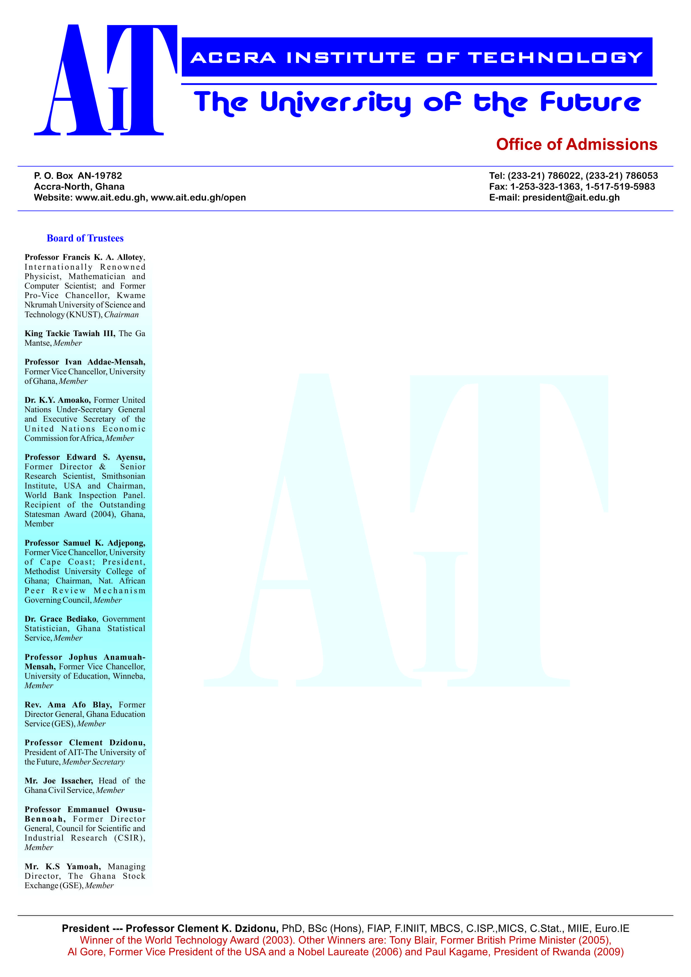

**END OF SEMESTER EXAMINATIONS**

2ND SEMESTER 2022/2023 ACADEMIC YEAR

DATE: JULY 2023

**COURSE CODE: EEE303/CE303**

**COURSE TITLE: COMMUNICATION SYSTEM 1**

**LECTURER’S NAME: NATHANIEL AWUDU NELSON**

**DURATION: 3 HOURS**

**APPENDICES**

|  |  |  |
| --- | --- | --- |
|  | **COURSE OUTLINE**  **(MAIN TOPICS)** | **QUESTION NO.** |
| **MajorTopic-1** | **FM Transmission System** | Q1 |
| **MajorTopic-2** | Teletraffic engineering | Q2, Q6d |
| **MajorTopic-3** | **Mode of Transmission** | Q3, Q4 |
| **MajorTopic-4** | Packet based communication | Q5 |
| **MajorTopic-5** | **Communication Parameters** | Q6a |
| **MajorTopic-6** | **Packet Based Com** | Q6b, Q6c, Q9a |
| **MajorTopic-7** | **Frequency Modulation/ Shannon Theory** | Q7c, Q7d, Q9a |
| **MajorTopic-8** | OSI reference model | Q7a |
| **MajorTopic-9** | **Transmission Network** | Q7b |
| **MajorTopic-10** | **Frequency Modulation/AM** | Q8a, Q9c, Q9d, Q9b |
| **MajorTopic-11** | **Network Performance Measures/Formatting** | Q8b, Q8c, |
| **MajorTopic-12** | Communication system | Q8d |
| **MajorTopic-13** | Digital and Analog modulation | Q10a |
| **MajorTopic-14** | **Noise In Communication** | Q10b, Q10d |
| **MajorTopic-15** | **Index of Modulation** | Q10c |
| **………….** |  |  |

**PART A (UNDERSTANDING)**

**INSTRUCTIONS: Part A contains FIVE questions. Answer ALL questions.**

**Questions**

Distinguish between a detector and a tuner in a RadioTransmitter.

|  |  |  |
| --- | --- | --- |
| **Major Topic**  **FM Transmission System** | **Blooms Designation**  **UN** | **Score**  **5** |

1. Differentiate between General communication and

Electronics communication.

|  |  |  |
| --- | --- | --- |
| **Major Topic**  **Communication Network** | **Blooms Designation**  **UN** | **Score**  **5** |

1. Give the main objective of teletraffic engineering in

communication network.

|  |  |  |
| --- | --- | --- |
| **Major Topic**  Teletraffic engineering | **Blooms Designation**  **UN** | **Score**  **5** |

1. Differentiate between DE-Modulation and DE- Multiplexing

in communication networks.

|  |  |  |
| --- | --- | --- |
| **Major Topic**  **Mode of Transmission** | **Blooms Designation**  **UN** | **Score**  **5** |

1. What do you mean by Packet based communication in

data transmission and its advantage?

|  |  |  |
| --- | --- | --- |
| **Major Topic**  Packet based communication | **Blooms Designation**  **UN** | **Score.**  **5** |

**TOTAL SCORE: 25 MARKS**

**PART B[APPLICATION AND ANALYSIS]**

**INSTRUCTIONS: Part B contains THREE questions. Attempt any TWO questions.**

|  |
| --- |
|  |

**Question 6.**

1. Network Information transfer is one of the key things that brings about sharing of messages. To realize this phenomenon to the later as telecom project manager, discuss the various parameters that will bear to achieve this. In your discussion give detail in all the parameters and single out the parameter that is responsible for propagation of the signal and explain it into detail not more than two pages

|  |  |  |
| --- | --- | --- |
| **Major Topic**  **Communication Parameters** | **Blooms Designation**  AP | **Score**  **7** |

1. To counter measure attacks in our network, access control is

implemented to protect what? Discuss these primary goals.

|  |  |  |
| --- | --- | --- |
| **Major Topic**  **Network Security** | **Blooms Designation**  AN | **Score**  **7** |

c) In packet communication which ensures fairness in resource sharing,

can be well analyzed with the solution of these two problems below.

1. 20MB file transferred across a network with 56kbs capacity, will

take about what time to transmit the packets?

1. Suppose the above file is broken into 2000-byte packets, how much

time will it take to transmit the packets? Comment on the two answers.

|  |  |  |
| --- | --- | --- |
| **Major Topic**  **Packet Based Com** | **Blooms Designation**  AP | **Score**  **6** |

d) i. Compute the call arrival rate in hours, given traffic intensity

of 20 Erlang and mean holding time of 36 seconds.

ii. What happens if there are no protocols in our networks?

|  |  |  |
| --- | --- | --- |
| **Major Topic**  **Frequency Modulation** | **Blooms Designation**  AN | **Score**  **5** |

**TOTAL SCORE: 25 MARKS**

**Question 7**

a i. What are the prime objectives of the OSI reference model?

ii. Discuss any three of the Open Systems Interconnection

(OSI) reference model.

|  |  |  |
| --- | --- | --- |
| **Major Topic**  OSI reference model | **Blooms Designation**  AP | **Score**  **7** |

b) i. Power in Amplitude Modulation at 100% Modulation

An un modulated AM signal produces a current of 7.3 A.

If the modulation is 100 percent, calculate

1. the carrier power

2. the total power

3. the sideband power when it is transmitted through an antenna having an impedance 60 Ω.

|  |  |  |
| --- | --- | --- |
| **Major Topic**  **Transmission Network** | **Blooms Designation**  AN | **Score**  **7** |

c.

An AM carrier wave of frequency f = 1MHz with pack voltage of 20V used to modulated a signal of frequency 1 kHz with pack voltage of 10v. Determine

1. Modulation index (μ)

2. Frequencies of modulated wave?

3. Bandwidth deviation of about 50 kHz. Find the bandwidth?

|  |  |  |
| --- | --- | --- |
| **Major Topic**  **Frequency Modulation** | **Blooms Designation**  AP | **Score**  **6** |

1. i. A communication network has a bandwidth of 10 kHz.

Calculate the signal-to-noise ratio in dB if the capacity

of the channel for a 100Kbps.

ii. A communications channel with a bandwidth of 4 kHz

has a signal power to noise ratio of 7. Determine the

Channel Capacity.

|  |  |  |
| --- | --- | --- |
| **Major Topic**  **Shannon Theory** | **Blooms Designation**  AN | **Score**  **5** |

**TOTAL SCORE: 25 MARKS**

**Question 8**

a) i. If the amplitude of the modulation signal voltage was given to be -4v and +4v and carrier amplitude also given to be -22v and +22v, by suitable waveform diagram determine the Am modulated output. Remember to provide **all necessary wave forms in practical terms**.

**ii.** If a sine wave is used to deviate the carrier, the expression for the frequency at any instant would be expressed as.

|  |  |  |
| --- | --- | --- |
| **Major Topic**  **Frequency Modulation/AM** | **Blooms Designation**  AP | **Score**  **7** |

b) To prove your knowledge as transmission planning engineer

in AIT telecom Unit, you are show that values of U which approaches one (1) brings about delay. Analyze this by a delay curve or graph. Choose values of U from 0.0 to 1.0 and D from 1 to 10.

|  |  |  |
| --- | --- | --- |
| **Major Topic**  **Network Performance Measures** | **Blooms Designation**  AN | **Score**  **7** |

1. Channel Capacity(C) was found to be 1.44 S/No where S

represent signal power and No is the Noise power. Discuss

in detail what 1.44 S/No means by a proof.

|  |  |  |
| --- | --- | --- |
| **Major Topic**  **Shannon Theory** | **Blooms Designation**  AP | **Score**  **6** |

d) Communication system after the message signal has been sent through the system, the speaker output was found not to be able to produce the desire output to satisfy the customers. After investigation, it was observed that the frequency was very high just as it was transmitted. Discuss what really went wrong in the transmission process and what measure will you take to avert to situation? You will be expected to come out with all processes involved.

|  |  |  |
| --- | --- | --- |
| **Major Topic**  Communication system | **Blooms Designation**  AN | **Score**  **5** |

**TOTAL SCORE: 25 MARKS**

**PART C [EVALUATING AND CREATING]**

**INSTRUCTIONS: Part C contains TWO questions. Answer ONE question.**

|  |
| --- |
|  |

**Question 9**

1. In an FM Communication system configured to operate in Accra International trade fair Centre for an upcoming fair organized by Ghana Tourism Ministry, the load current was given as 4A.



Carrier deviation is given as 6.33KHz.

1. Determine the parameter that art as an indicator of level

of modulation.

1. The voltage magnitude.
2. Carrier frequency of the entire circuit.

|  |  |  |
| --- | --- | --- |
| **Major Topic**  Frequency Modulation | **Blooms Designation**  **CR** | **Score**  **7** |

b) In a switching network the channel capacity was given as 4 and the traffic intensity of 3 Erlang. What will be the call congestion of the switch? If the grade of service is given as 1.2%, comment on the outcome as project engineer to management.

|  |  |  |
| --- | --- | --- |
| **Major Topic**  Teletraffic engineering | **Blooms Designation**  **EV** | **Score**  **7** |

c) If an AM signal is represented by



1. Calculate the values of the frequencies of carrier

and modulating signals.

ii.) Calculate the value of modulation index.

iii.) Calculate the value of bandwidth of this signal.

|  |  |  |
| --- | --- | --- |
| **Major Topic**  **Amplitude Modulation** | **Blooms Designation**  **CR** | **Score**  **7** |

d)An AM signal has a total power of 48 Watts with 45% modulation. Calculate the power in the carrier and the sidebands.

|  |  |  |
| --- | --- | --- |
| **Major Topic**  **Amplitude Modulation** | **Blooms Designation**  **EV** | **Score**  **4** |

**TOTAL SCORE: 25 MARKS**

**Question 10**

1. With the aid of a suitable wave form diagram distinguish between analog and digital modulation types in our communications systems. Provide both digital and analog wave forms.

|  |  |  |
| --- | --- | --- |
| **Major Topic**  Digital and Analog modulation | **Blooms Designation**  **CR** | **Score**  **7** |

b) In a single-sideband (SSB) signal which is transmitted over a noisy channel, with the power spectral density of the noise.

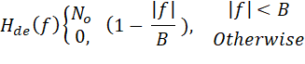

For B = 200 kHz and No = 10−9 W/Hz. The message has bandwidth 10 kHz and average power 10 W. The carrier amplitude at the transmitter is 1 V. Assume the channel attenuates the signal power by a factor of 1000, i.e., 30 decibels (dB). Assume the lower sideband (LSB) is transmitted and a suitable bandpass filter is used at the receiver to limit the out-of-band noise. Determine the predetection SNR at the receiver if

1. the carrier frequency is 100 kHz;
2. the carrier frequency is 200 kHz.

|  |  |  |
| --- | --- | --- |
| **Major Topic**  **Noise In Communication** | **Blooms Designation**  **EV** | **Score**  **7** |

c) Broadcast stations in particular take measures to ensure that

the carriers of their transmissions never be found in a situation where it will experience phase reversal. In the event where phase reversal emerges, how would you savage the effect? Also provide a graphical representation of this effect

|  |  |  |
| --- | --- | --- |
| **Major Topic**  **Index of Modulation** | **Blooms Designation**  **CR** | **Score**  **5** |

d) i. By what means can you prove that Thermal noise is often refered to as white noise and why.

1. How does short noise occur in semiconductors?
2. Calculate the reverse saturation current(amps) where



B =3.4KHz.

**iv.** To analyse noise in communication systems, by the application of resistance in parallel, show that



and



|  |  |  |
| --- | --- | --- |
| **Major Topic**  **Noise In Communication** | **Blooms Designation**  **EV** | **Score**  **6** |

**TOTAL SCORE: 25 MARKS**

**END OF QUESTION PAPER**