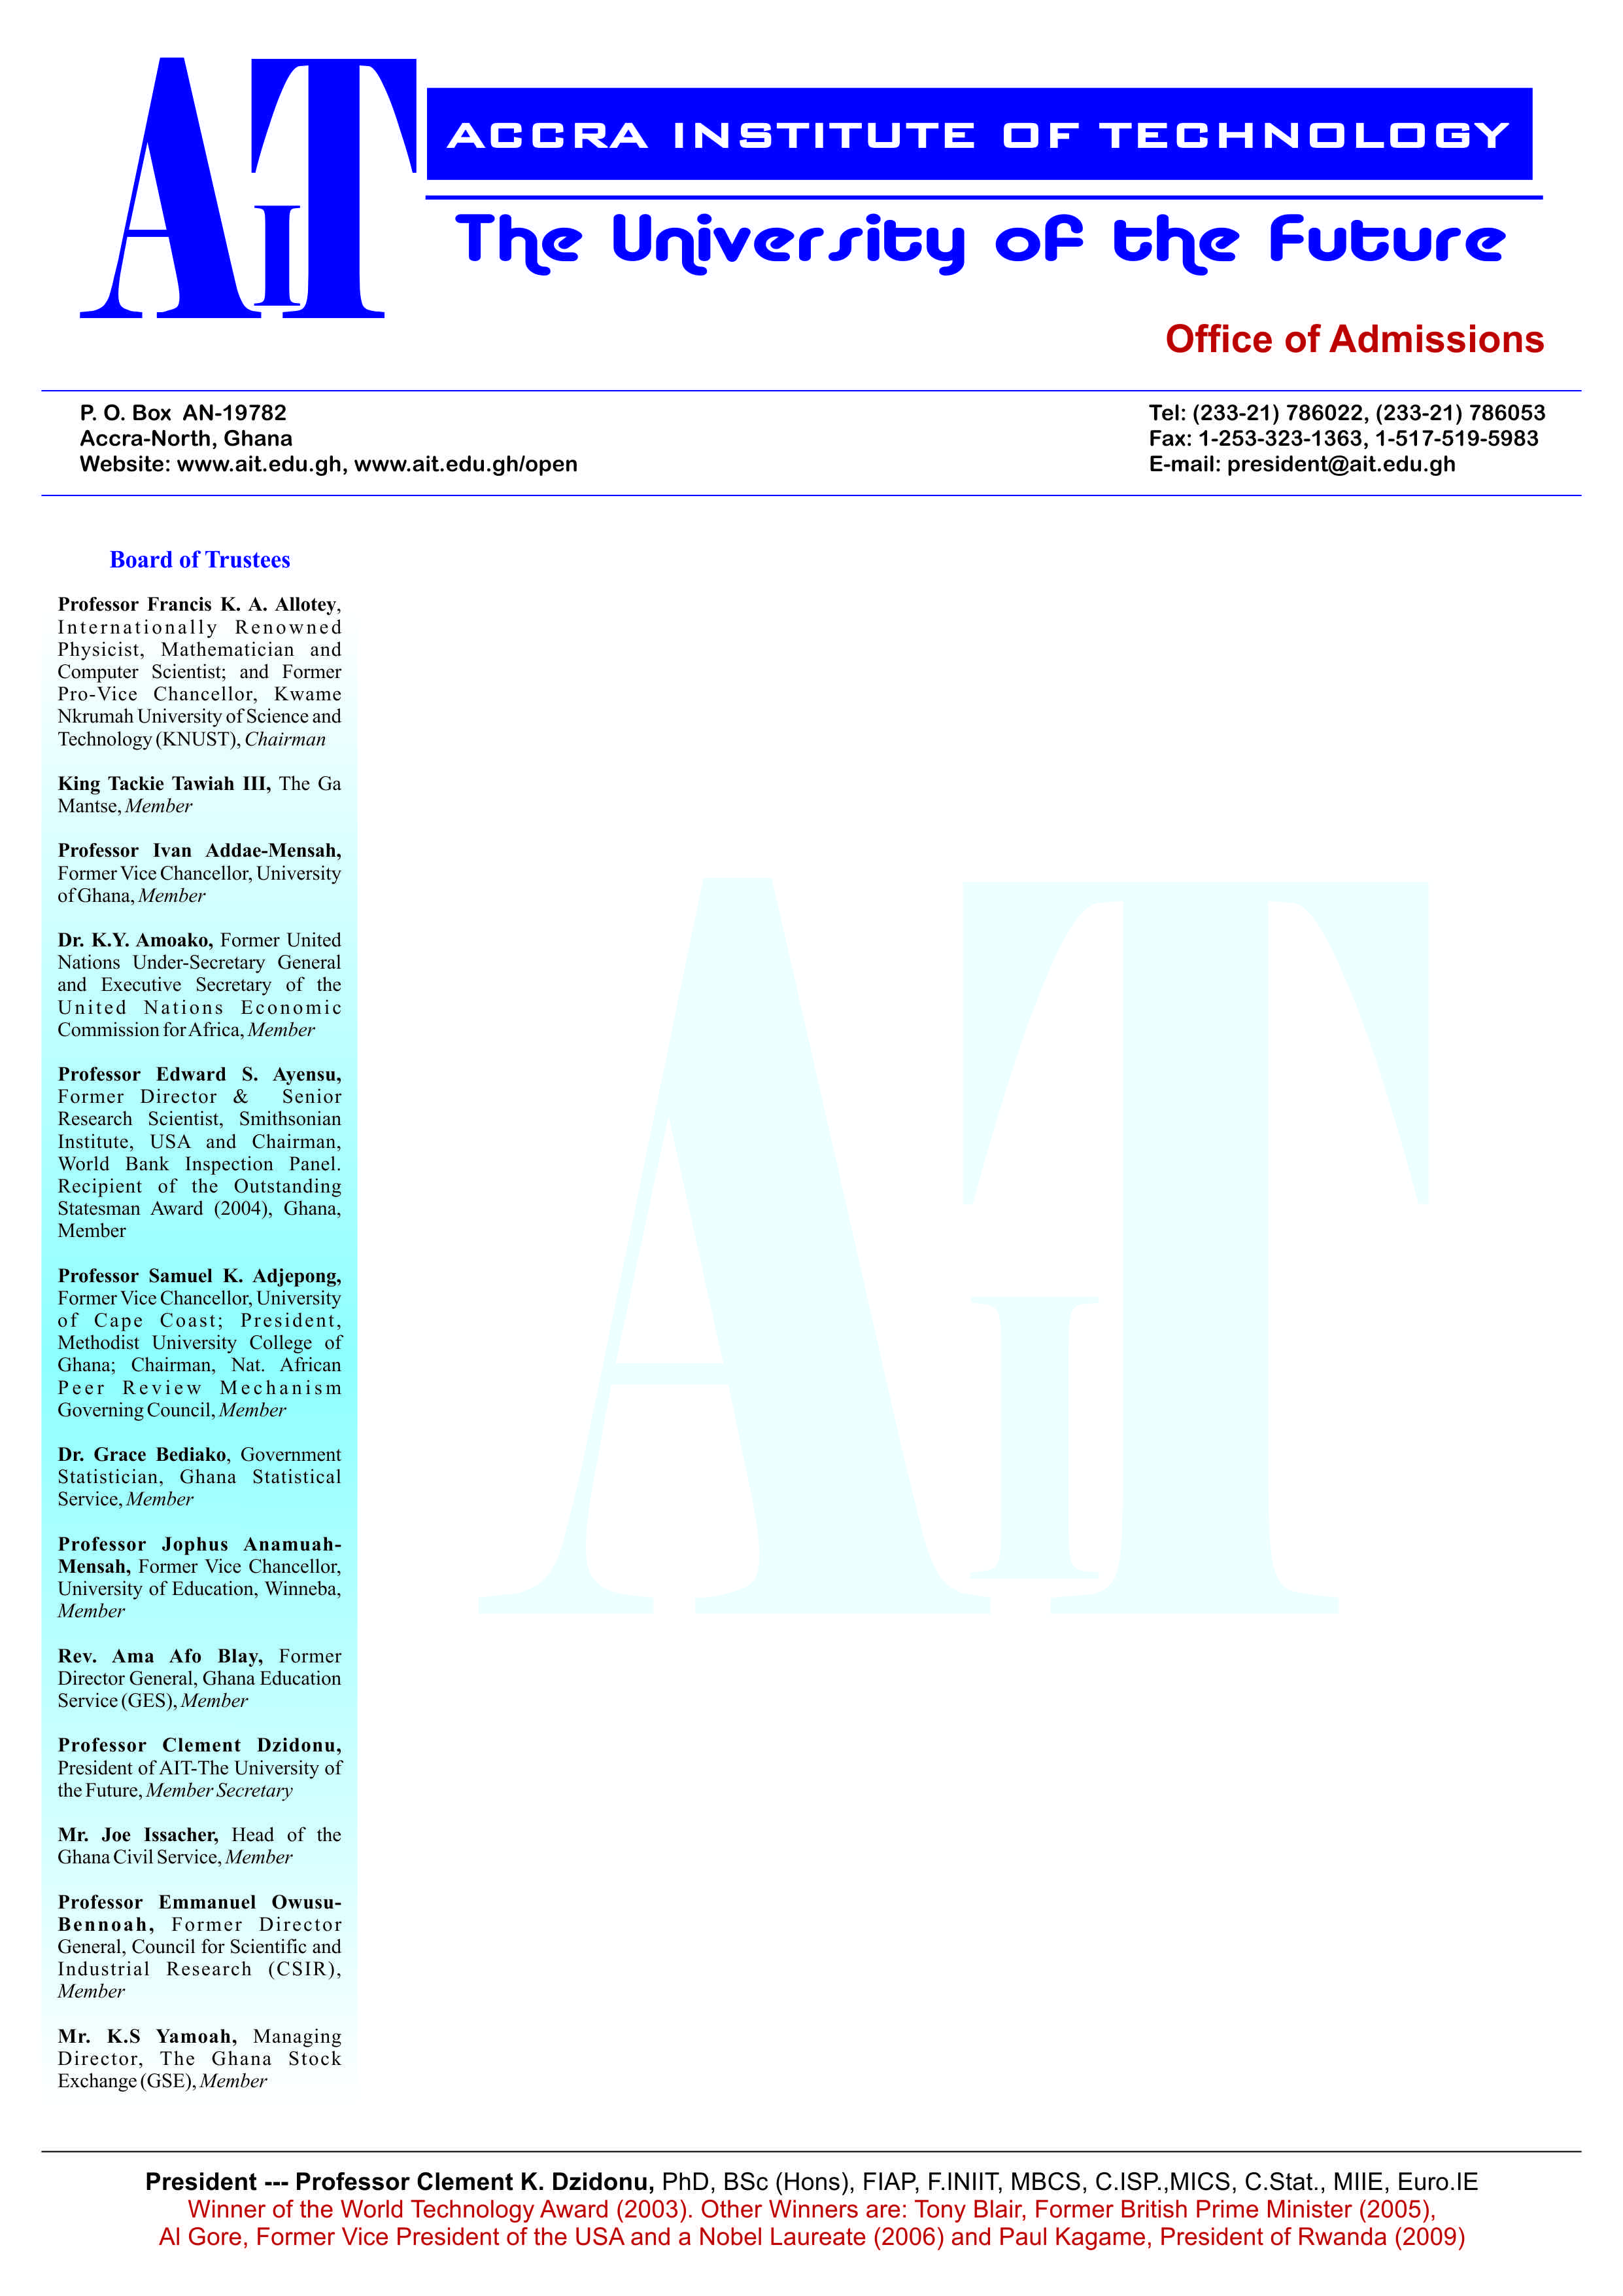

**END OF SEMESTER EXAMINATIONS**

2ND SEMESTER 2022/2023 ACADEMIC YEAR

DATE: JULY 2023

**COURSE CODE: EEE 203**

**COURSE TITLE: SIGNALS AND SYSTEMS**

**LECTURER’S NAME: DR. MAHAMUDA ALHAJI AMAHAMADU**

**DURATION: 3 HOURS**

**APPENDICES**

|  |  |  |
| --- | --- | --- |
|  | **COURSE OUTLINE**  **(MAIN TOPICS)** | **QUESTION NO.** |
| **MajorTopic-1** | **Elementary Signals** | **1, 6a, 7d** |
| **MajorTopic-2** | **Even and Odd Signals** | **6b,9b** |
| **MajorTopic-3** | **Applications of Signals and Systems** | **3, 6c** |
| **MajorTopic-4** | **Periodic and Non-periodic Signals** | **2, 4,7a, 9c, 9d** |
| **MajorTopic-5** | **Energy and Power Signals** | **5, 7b,10b, 10c, 10d** |
| **MajorTopic-6** | **Causal and Non Causal Systems** | **7c** |
| **MajorTopic-7** | **Time Variant and Time Invariant System** | **6d, 8a,** |
| **MajorTopic-8** | **Causal and Non-causal systems** | **6d** |
| **MajorTopic-9** | **Static system or a dynamic system** | **8b** |
| **MajorTopic-10** | **Linear and Non-linear Systems** | **8c** |
| **MajorTopic-11** | **Discrete-Time Systems** | **9a , 10a, 10c, 10d** |
| **MajorTopic-12** | **Stable and Non-Stable System** | **8d** |

**PART A (UNDERSTANDING)**

**INSTRUCTIONS: Part A contains FIVE questions. Answer ALL questions.**

**Questions**

1. In your own words define a **unit step signal** and a unit **delta signal**. With the aid id of an equation state the relationship betweena **unit step** signal and a **unit delta** signal

|  |  |  |
| --- | --- | --- |
| Major Topic  Elementary Signals | Blooms Designation  UN | **Score**  **5** |

2. In your own words distinguish between a periodic **signal** and an **aperiodic signal**

|  |  |  |
| --- | --- | --- |
| Major Topic  Periodic and Aperiodic Signals | Blooms Designation  UN | **Score**  **5** |

3. Signals and Systems is a discipline that finds application in engineering, science and technology. Write briefly on the application of signal and systems in **health.**

|  |  |  |
| --- | --- | --- |
| Major Topic  Applications of Signals and Systems | Blooms Designation  UN | **Score**  **5** |

4. Explain why discrete-time signals are aperiodic

|  |  |  |
| --- | --- | --- |
| Major Topic  Periodic and Non-periodic Signals | Blooms Designation  UN | **Score**  **5** |

**5.** Determine whether the signal x (t) = e-at u (t) with a>0 is an energy or power signal or neither

|  |  |  |
| --- | --- | --- |
| Major Topic  Energy and Power Signals | Blooms Designation  UN | **Score.**  **5** |

**TOTAL SCORE: 25 MARKS**

**PART B[APPLICATION AND ANALYSIS]**

**INSTRUCTIONS: Part B contains THREE questions. Attempt any TWO questions.**

|  |
| --- |
|  |

**Question 6.**

1. With the aid of graphs differentiate between the **ramp function** and the **unit delta function**. Determine the **unit ramp function** from the **unit delta function**

|  |  |  |
| --- | --- | --- |
| Major Topic  Elementary Signals | **Blooms Designation**  AP | **Score**  **7** |

1. Any signal can be expressed as a sum of two signals, one of which is **even** and one of which is **odd**. Derive the formulae for the even and odd component of a signal x(t). Determine the even and odd components of the signal given below

x(t)=ejt

|  |  |  |
| --- | --- | --- |
| Major Topic  Even and Odd Signals | **Blooms Designation**  AN | **Score**  **7** |

1. Signals and Systems is a discipline that finds application in engineering, science and technology. In your own words, clearly explain the use of signals and systems in **telecommunication**

|  |  |  |
| --- | --- | --- |
| Major Topic  Applications of Signals and Systems | **Blooms Designation**  AP | **Score**  **6** |

d) Distinguish between a **time-variant system** and a **time-invariant system**

|  |  |  |
| --- | --- | --- |
| Major Topic  Time-variant and Time-invariant Systems | **Blooms Designation**  AN | **Score**  **5** |

**TOTAL SCORE: 25 MARKS**

**Question 7**

a) Using mathematical formulations distinguish between **period signals** and **non-periodic signals**. Determine whether the signals below are periodic signals or non-periodic signals. If a signal is periodic signal find its period.

i. x(t)=Cos5пt +Sin60 пt

ii. x(t)=3(19пt –п/3)

|  |  |  |
| --- | --- | --- |
| Major Topic  Periodic and Non-periodic Signals | **Blooms Designation**  AP | **Score**  **7** |

b) Differentiate between an **energy signal** and a **power** **signal**. Determine whether the signal below is an energy signal or power signal or neither. x(t)=Acos(ωot + ϴ)

|  |  |  |
| --- | --- | --- |
| Major Topic  Energy and Power Signals | **Blooms Designation**  AN | **Score**  **7** |

c) Determine whether the system below is a causal or non-causal and give a reason for your answer.

y(n)= nx(n)

|  |  |  |
| --- | --- | --- |
| Major Topic  Causal and Non Causal Systems | **Blooms Designation**  AP | **Score**  **6** |

d) With the aid of mathematical formulae define **step** and **impulse functions** in **discrete signals**

|  |  |  |
| --- | --- | --- |
| Major Topic  Elementary Signals | **Blooms Designation**  AN | **Score**  **5** |

**TOTAL SCORE: 25 MARKS**

**Question 8**

a) In your own words, distinguish between a **time invariance system** and a **time variant system.** Determine whether the system below is a **time invariant system or a time variant system**. y[n]=x[2n]

|  |  |  |
| --- | --- | --- |
| Major Topic  Time Variant and Time Invariant System | **Blooms Designation**  AP | **Score**  **7** |

b) Distinguish between a static system and a dynamic system and determine whether the systems below are a static system or a dynamic system. Give reason for your answer i. y(t)=5x(t-1) +20x(t-2)

ii. y(t)=e-(t+1)x(t)

|  |  |  |
| --- | --- | --- |
| Major Topic  Static system or a dynamic system | **Blooms Designation**  AN | **Score**  **7** |

c) In your own words, explain the difference between **a linear system** and **non-linear system**. Determine whether the system below is a linear system or a non-linear system.

y(t)=x(cost)

|  |  |  |
| --- | --- | --- |
| Major Topic  Linear and Non-linear Systems | **Blooms Designation**  AP | **Score**  **6** |

d) In your own words distinguish between a **stable system** and a **non-stable system**

|  |  |  |
| --- | --- | --- |
| Major Topic  Stable and Non-Stable System | **Blooms Designation**  AN | **Score**  **5** |

**TOTAL SCORE: 25 MARKS**

**PART C [EVALUATING AND CREATING]**

**INSTRUCTIONS: Part C contains TWO questions. Answer ONE question.**

|  |
| --- |
|  |

**Question 9**

1. Determine the overall operator H of a system whose output signal y[n] is given by

y[n]= 2[ x(n+1)+x(n)+x(n-1)]

Draw its cascade block diagram

|  |  |  |
| --- | --- | --- |
| Major Topic  Discrete-time systems | **Blooms Designation**  **CR** | **Score**  **7** |

1. Prove that if x1(n) is an **even** signal and x2(n) is an **even** signal their product is an **even signal**

|  |  |  |
| --- | --- | --- |
| Major Topic  Even and Odd Signals | **Blooms Designation**  **EV** | **Score**  **7** |

1. Determine whether the signal below is periodic. If it is periodic find its fundamental period

X(t)= Cos пt/3+ Sin пt/4

|  |  |  |
| --- | --- | --- |
| Major Topic  Periodic and Non-periodic Signals | **Blooms Designation**  **CR** | **Score**  **6** |

d) Determine if the continuous-time signal x(t) = ejωt is periodic or not. If period find its fundamental period

|  |  |  |
| --- | --- | --- |
| Major Topic  Periodic and Non-periodic Signals | **Blooms Designation**  **EV** | **Score**  **5** |

**TOTAL SCORE: 25 MARKS**

**Question 10**

a) Determine the overall operator H of a system whose output signal y[n] is given by

**y[n]=** and draw its cascade block diagram.

|  |  |  |
| --- | --- | --- |
| Major Topic  Discrete-time systems | **Blooms Designation**  **CR** | **Score**  **7** |

b) Using mathematical formulations distinguish between Energy signals and power signals

|  |  |  |
| --- | --- | --- |
| Major Topic  Energy and Power Signals | **Blooms Designation**  **EV** | **Score**  **7** |

c) Determine whether the signal below is an energy or power signal or neither.

x[n]=u[n]

|  |  |  |
| --- | --- | --- |
| Major Topic  Energy and Power Signals | **Blooms Designation**  **CR** | **Score**  **6** |

1. Determine whether the signal below is an energy or power signal or neither

x(t)={t 0≤ t ≤ 1 , 2-t 1≤ t ≤ 2, 0 otherwise

|  |  |  |
| --- | --- | --- |
| Major Topic  Energy and Power Signals | **Blooms Designation**  **EV** | **Score**  **5** |

**TOTAL SCORE: 25 MARKS**

**END OF QUESTION PAPER**