

**END OF SEMESTER EXAMINATIONS**

2ND SEMESTER 2022/2023 ACADEMIC YEAR

DATE: JULY 2023

**COURSE CODE: CVE537**

**COURSE TITLE: TRANSPORTATION SYSTEMS & ROADWAY GEOMETRIC DESIGN**

**LECTURER’S NAME: *ING. ISRAEL TETTEH APPIAH***

**DURATION: 3 HOURS**

**APPENDICES**

|  |  |  |
| --- | --- | --- |
|  | **COURSE OUTLINE**  **(MAIN TOPICS)** | **QUESTION NO.** |
| **MajorTopic-1** | **Introduction to Transport Systems** | Q1, Q3, Q6a |
| **MajorTopic-2** | **Introduction to Transport Planning** | Q6b, Q6c, Q6d, Q7a, Q7c, Q7d, Q8d, Q10a, Q10b, Q10d |
| **MajorTopic-3** | **Transport Systems Design** | Q2, Q8b, Q8c, Q9d |
| **MajorTopic-4** | **Transport Planning** | Q8a |
| **MajorTopic-5** | **Fundamental of traffic signal design** | Q7b, Q9a, Q9b, Q9c, Q10c |

**PART A (UNDERSTANDING)**

**INSTRUCTIONS: Part A contains FIVE questions. Answer ALL questions.**

**Questions**

1. Define *Transportation Engineering* and *Traffic Engineering*. Describe three difference between them.

|  |  |  |
| --- | --- | --- |
| **Major Topic**  **01 Introduction to Transport Systems (Slide 6)** | **Blooms Designation**  **UN** | **Score**  **5** |

2.  State five transport institutional policies that supports the designing for operations approach.

|  |  |  |
| --- | --- | --- |
| **Major Topic**  **03 Transport System Design (Slide 22)** | **Blooms Designation**  **UN** | **Score**  **5** |

3. Explain the following as applied to transportation:

i. Demand as a derived-function of transportation. ii. Nodes

iii. Networks iv. Flows v. Facilities

|  |  |  |
| --- | --- | --- |
| **Major Topic**  **01 Introduction to Transport Systems (Slide 15-16)** | **Blooms Designation**  **UN** | **Score**  **5** |

4. The forecasted trip productions in Weija and Old Barrier, and the attractiveness of Kaneshie, Circle and Accra Central are presented in Table 1. If the travel times in minutes between the production and attractions zones obtained from a trip data collection are as presented in Table 2 and socioeconomic adjustment factors in Table 3, distribute the trips from Weija and Old Barrier to Kaneshie, Circle and Accra Central by assuming the frictional factor constant, c = 2.

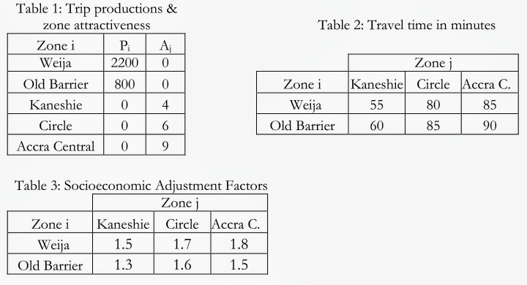

|  |  |  |
| --- | --- | --- |
| **Major Topic** | **Blooms Designation**  **UN** | **Score**  **5** |

5. The table below indicates the links of the road network of certain suburbs of Accra and the travel time in minutes from one suburb to the other. Using a tree table, determine the minimum paths from AIT Campus to all other suburbs.

|  |  |
| --- | --- |
| **Link** | **Travel Time (min)** |
| AIT Campus – Block Factory | 2y |
| Block Factory – Barrier | 3y |
| Barrier – Weija | 2y |
| Barrier – Aplaku | 6y |
| Weija – Gbawe | 4y/2 |
| Weija – Mallam Junction | 3y |
| Gbawe – Mallam | y |
| Mallam – Mallam Junction | y |
| Mallam Junction – Sakaman Junction | 2y |
| Sakaman Junction – Darkuman Junction | y/2 |
| Sakaman Junction – Dansoman | 5y/2 |
| Darkuman Junction – Dansoman | y |
| Darkuman Junction – Darkuman | 3y/2 |
| Darkuman Junction – Kaneshie | 3y/2 |
| Dansoman – Mataheko | y/2 |
| Darkuman – Kanshie | 3y |
| Mataheko - Kaneshie | y |

|  |  |  |
| --- | --- | --- |
| **Major Topic**  **2.1 Fundamentals of Traffic Flow (Slide 12)** | **Blooms Designation**  **UN** | **Score.**  **5** |

**TOTAL SCORE: 25 MARKS**

**PART B[APPLICATION AND ANALYSIS]**

**INSTRUCTIONS: Part B contains THREE questions. Attempt any TWO questions.**

a) Bridget belongs to the same household with her mother and grandfather who is 80yrs old. Bridget’s grandfather owns a private car, but due to his old age, he is not able to drive himself, but only uses the car when Bridget’s mother is available to drive him. When Bridget’s mother is not available, Bridget’s grandfather uses public transport. Bridget cannot drive and always uses public transport. Bridget’s mother only uses the vehicle when she has to drive Bridget’s grandfather, otherwise she uses the public transport. What categories of trip makers or transport user groups do Bridget, her mother and the grandfather belongs to and why?

|  |  |  |
| --- | --- | --- |
| **Major Topic**  **02 Introduction to Transport Systems (Slide 39-40)** | **Blooms Designation**  AP | **Score**  **7** |

b) The following table is an urban zone’s expected household composition at some future year.

|  |  |  |  |  |
| --- | --- | --- | --- | --- |
| **Vehicle per household** | **Persons per household** | | | |
| **1** | **2,3** | **4** | **5** |
| 0 | 100 | 200 | 150 | 20 |
| 1 | 300 | 500 | 210 | 50 |
| 2+ | 150 | 100 | 60 | 0 |

The calibrated total home-based non-work trip rates for the high- and medium-density areas of the zone are as given in this table:

|  |  |  |  |  |  |
| --- | --- | --- | --- | --- | --- |
| **Cross Class** | | **Persons per household** | | | |
|  | **Vehicles per household area type** | **1** | **2,3** | **4** | **5+** |
| **Urban high density** | 0  1  2+ | 0.57  1.45  1.82 | 2.07  3.02  3.39 | 4.57  5.52  5.89 | 6.95  7.90  8.27 |
| **Urban medium density** | 0  1  2+ | 0.97  1.92  2.29 | 2.54  3.49  3.86 | 5.04  5.99  6.36 | 7.42  8.37  8.74 |

Estimate the total non-work home-based trips that the urban high-density and the urban medium density area of the zone will produce on a typical day in the horizon year.

|  |  |  |
| --- | --- | --- |
| **Major Topic**  **02 Introduction to Transport Planning (Slide 20-21)** | **Blooms Designation**  AN | **Score**  **7** |

c) Explain the following terminologies in modal split theory:

i. transport disadvantage groups ii. transit-captives or captive riders

iii. non-transport disadvantage groups

|  |  |  |
| --- | --- | --- |
| **Major Topic**  **02 Introduction to Transport Planning (Slide 39-40)** | **Blooms Designation**  AP | **Score**  **6** |

d) Explain the end of trip generation analysis with respect to *zone centroid* and *zone boundary*.

|  |  |  |
| --- | --- | --- |
| **Major Topic**  **02 Introduction to Transport Planning (Slide 22)** | **Blooms Designation**  AN | **Score**  **5** |

**TOTAL SCORE: 25 MARKS**

**Question 7**

a) For a certain OD pair there are two mode alternatives, car and bike. Travelers are assumed to consider two attributes: costs and travel time (see table below).

|  |  |  |
| --- | --- | --- |
|  | **Cost, c** | **Travel time, t*i* (min)** |
| **Car** | 2.00 | 10 |
| **Bike** | 0.10 | 30 |

Travelers are assumed to maximize their utility given by *Vi = - (αti +ci*); where α is the value of time (VOT).

(i) What value should at least be for the car to be the preferred alternative?

(ii) If there is also a bus connection available with travel time 20 min., what is the maximum price the bus should charge? Assume the VOT is the same as computed in (i).

|  |  |  |
| --- | --- | --- |
| **Major Topic**  **02 Introduction to Transport Planning** | **Blooms Designation**  AP | **Score**  **7** |

b) Explain the following traffic-signal-related terminologies:

i. Cycle time or cycle length ii. All-red period or clearance time

iii. Change interval or yellow interval iv. Protected-left-turn

v. Permitted-left-turn vi. Demand-actuated signals

vii. Fully-actuated signals

|  |  |  |
| --- | --- | --- |
| **Major Topic**  **04 Fundamental of traffic signal design (Slide 8-20)** | **Blooms Designation**  AN | **Score**  **7** |

c) Explain the following terminologies in network assignments theory:

i. free/all-or-nothing traffic assignment ii. multi-path traffic assignment

iii. capacity-restrained traffic assignment

|  |  |  |
| --- | --- | --- |
| **Major Topic**  **02 Introduction to Transport Planning (Slide 46-54)** | **Blooms Designation**  AP | **Score**  **6** |

d) Explain the end of trip distribution analysis with respect to *zone centroid*.

|  |  |  |
| --- | --- | --- |
| **Major Topic**  **02 Introduction to Transport Planning (Slide 34)** | **Blooms Designation**  AN | **Score**  **5** |

**TOTAL SCORE: 25 MARKS**

**Question 8**

1. Consider two zones with the following data:

|  |  |  |
| --- | --- | --- |
|  | **Number of inhabitants** | **Number of jobs** |
| **Zone A** | 1000 | 300 |
| **Zone B** | 800 | 200 |

The number of inhabitants has been determined with a higher precision than the number of jobs. On average, the number of departing trips is 0.25 per inhabitant, and the number of arriving trips is 0.8 per job. All the travel resistances (intrazonal and interzonal) may be assumed equal. Determine the trip distribution.

|  |  |  |
| --- | --- | --- |
| **Major Topic**  **02 Transportation Planning (Slide 46)** | **Blooms Designation**  AP | **Score**  **7** |

b) Explain the following terminologies associated with transit service and capacity:

i. Clearance time ii. Cush capacity

iii. Dwell time iv. Layover/Recovery/Terminal time

v. Load factor vi. Fleet size

vii. Round trip time

|  |  |  |
| --- | --- | --- |
| **Major Topic**  **03 Transport System Design (Slides 36-41)** | **Blooms Designation**  AN | **Score**  **7** |

c) Explain the following with respect to vehicle characteristics:

i. static characteristics ii. kinematic characteristics

iii. Dynamic characteristics

|  |  |  |
| --- | --- | --- |
| **Major Topic**  **03 Transport System Design (Slides 17)** | **Blooms Designation**  AP | **Score**  **6** |

d) Explain the end of modal split analysis with respect to *zone centroid*, *zone boundary* and *person trip ends*.

|  |  |  |
| --- | --- | --- |
| **Major Topic**  **02 Introduction to Transport Planning (Slide 38)** | **Blooms Designation**  AN | **Score**  **5** |

**TOTAL SCORE: 25 MARKS**

**PART C [EVALUATING AND CREATING]**

**INSTRUCTIONS: Part C contains TWO questions. Answer ONE question.**

|  |
| --- |
|  |

**Question 9**

A three-phase pre-timed signal system is designed to have a standard amber period of 4s and all-red period of 2s for each phase change. The configuration of the intersection and associated volumes is given below.

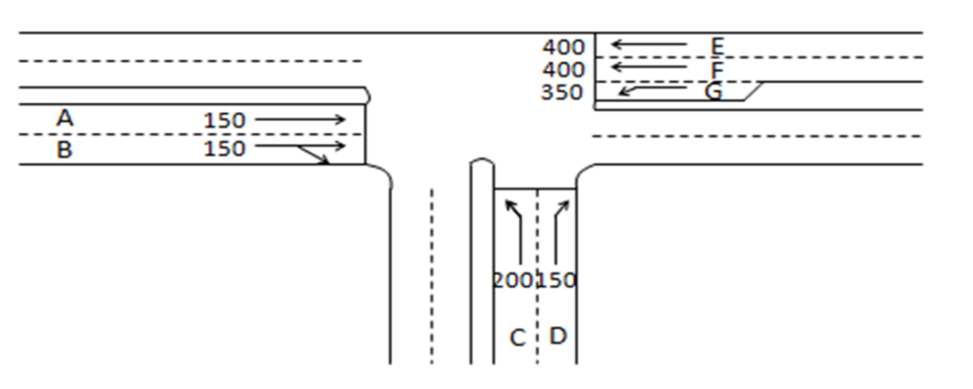

Volumes are in pcu/hr and have already been converted to DHV (PHV/PHF).

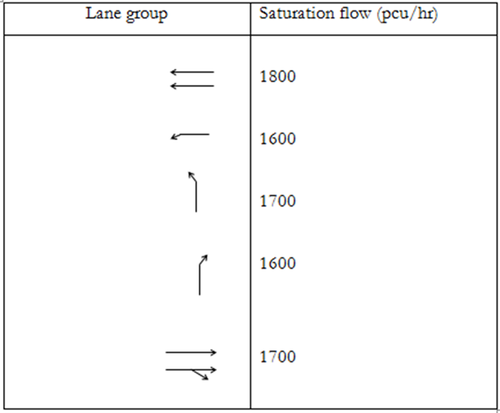

Using the diagram, the saturation flow data in the table below and Webster’s method above, determine:

1. The Optimum cycle length.

|  |  |  |
| --- | --- | --- |
| **Major Topic**  **04 Fundamental of traffic signal design (Slides 35-40)** | **Blooms Designation**  **CR** | **Score**  **7** |

1. The green time to be allocated to each phase.

|  |  |  |
| --- | --- | --- |
| **Major Topic**  **04 Fundamental of traffic signal design (Slides 35-40)** | **Blooms Designation**  **EV** | **Score**  **6** |

1. Sketch a representation of the signalization

|  |  |  |
| --- | --- | --- |
| **Major Topic**  **04 Fundamental of traffic signal design (Slides 35-40)** | **Blooms Designation**  **CR** | **Score**  **7** |

d) How would the following conditions affect the minimum stopping sight distance requirement?

i. A driver with blurred vision ii. A vehicle with worn out tyres

|  |  |  |
| --- | --- | --- |
| **Major Topic** | **Blooms Designation**  **EV** | **Score**  **5** |

**TOTAL SCORE: 25 MARKS**

**Question 10**

|  |  |  |  |  |  |  |  |  |  |  |  |  |  |  |  |  |  |  |  |  |  |  |  |
| --- | --- | --- | --- | --- | --- | --- | --- | --- | --- | --- | --- | --- | --- | --- | --- | --- | --- | --- | --- | --- | --- | --- | --- |
|  |  |  |  |  | Base year volumes (Qij) | | | |  | |  | |  | | Inter-zonal impedances (Wij) | | | | | | | |  |
| **Zone i** | **Pi** | **Ai** |  |  | |  | | | |  | |  | |  | |  |  | |  | |  |  | |
| 1 | 500 | 0 |  |  | | **Zone j** | | | | |  | | |  | | | **Zone j** | | | | |  | |
| 2 | 1000 | 0 |  | **Zone i** | | 3 | 4 | 5 | | |  | | | **Zone i** | | | 3 | 4 | | 5 | |  | |
| 3 | 0 | 2 |  | 1 | | 300 | 150 | 50 | | |  | | | 1 | | | 5 | 10 | | 15 | |  | |
| 4 | 0 | 3 |  | 2 | | 180 | 600 | 220 | | |  | | | 2 | | | 10 | 5 | | 15 | |  | |
| 5 | 0 | 5 |  |  | |  |  |  | | |  | | |  | | |  |  | |  | |  | |
|  |  |  |  |  | |  |  |  | | |  | | |  | | |  |  | |  | |  | |

a) Find the value of *c* for the base year trip data above:

|  |  |  |
| --- | --- | --- |
| **Major Topic**  **02 Introduction to Transport Planning (Slide 29-33)** | **Blooms Designation**  **CR** | **Score**  **7** |

b) Find the value of *Kij* for the following base year trip data above:

|  |  |  |
| --- | --- | --- |
| **Major Topic**  **02 Introduction to Transport Planning (Slide 29-33)** | **Blooms Designation**  **EV** | **Score**  **7** |

c) What is traffic conflict? With the aid of sketches, describe the three types of traffic conflicts that can occur at intersections.

|  |  |  |
| --- | --- | --- |
| **Major Topic**  **04 Fundamental of traffic signal design (Slide 4)** | **Blooms Designation**  **CR** | **Score**  **6** |

1. Would you say the ***all-or-nothing*** trip assignment technique mimics reality? Give reasons.

|  |  |  |
| --- | --- | --- |
| **Major Topic**  **02 Introduction to Transport Planning (Slide 43)** | **Blooms Designation**  **EV** | **Score**  **5** |

**TOTAL SCORE: 25 MARKS**

**MEMORY AID**

** **

** **

** **

** **



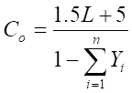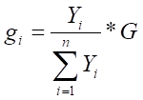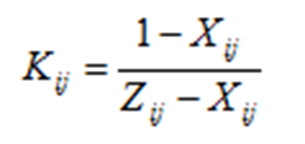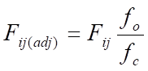

**END OF QUESTION PAPER**