

**END OF SEMESTER EXAMINATIONS**

2ND SEMESTER 2022/2023 ACADEMIC YEAR

DATE: JULY 2023

**COURSE CODE: CVE310**

**.**

**COURSE TITLE: Civil Engineering Quantities**

**LECTURER’S NAME: Ing Sarpong-Nsiah**

**DURATION: 3 HOURS**

**APPENDICES**

|  |  |  |
| --- | --- | --- |
|  | **COURSE OUTLINE**  **(MAIN TOPICS)** | **QUESTION NO.** |
| **MajorTopic-1** | Measurement of Dimension | 1 |
| **MajorTopic-2** | Estimates | 2, 5, 8c |
| **MajorTopic-3** | All Aspects of Construction | 3 |
| **MajorTopic-4** | Rate Analysis | 4 |
| **MajorTopic-5** | Pipework | 6c, 6a |
| **MajorTopic-6** | Reinforcement quantity estimation | 10d, 9b, 9b, 8a, 6d, |
| **MajorTopic-7** | Legal Responsibility | 7a |
| **MajorTopic-8** | Specification | 7b |
| **MajorTopic-9** | Causes of Dispute | 8b, 7c |
| **MajorTopic-10** | Concrete works | 9c, 7d |
| **MajorTopic-11** | Detailed Estimates | 8d |
| **MajorTopic-12** | Earthworks | 10a, 9a |
| **MajorTopic-13** | Abstract estimate | 10c, 9d |
| **MajorTopic-14** | Reinforcement | 6b,6d |

**PART A (UNDERSTANDING)**

**INSTRUCTIONS: Part A contains FIVE questions. Answer ALL questions.**

**Questions**

1. What can you say about details of measurement form?

|  |  |  |
| --- | --- | --- |
| Measurement of Dimension | **Blooms Designation**  **UN** | **Score**  **5** |

2. What can you say about abstract of estimate form?

|  |  |  |
| --- | --- | --- |
| Estimates | **Blooms Designation**  **UN** | **Score**  **5** |

3. What statement support specification of earthworks in building works?

|  |  |  |
| --- | --- | --- |
| All Aspects of Construction | **Blooms Designation**  **UN** | **Score**  **5** |

4. How would you summarize: ‘the process of determining rate per unit of any work in civil engineering project like earth works, plastering. painting etc is known as analysis of rates or simply rate analysis, the rates of these works further help in determining cost of particular work and in turn cost of the project’?

|  |  |  |
| --- | --- | --- |
| Rate Analysis | **Blooms Designation**  **UN** | **Score**  **5** |

5. What is the main function of abstract of estimate?

|  |  |  |
| --- | --- | --- |
| Estimates | **Blooms Designation**  **UN** | **Score.**  **5** |

**TOTAL SCORE: 25 MARKS**

**PART B: [APPLICATION AND ANALYSIS]**

**INSTRUCTIONS: Part B contains THREE questions. Attempt any TWO questions.**

|  |
| --- |
|  |

**Question 6.**

a) How would you apply the rules for the measurement of pipes and associated work?

|  |  |  |
| --- | --- | --- |
| Pipework | **Blooms Designation**  AP | **Score**  **7** |

b) A RCC beam of 4m. Clear span of 300mm width and 450mm depth. It consists of hanger bars, main longitudinal bars and bent up bars at the bottom as shown below. Stirrups at a spacing of 180 mm c/c are provided though out the length of the beam. The clear cover to the reinforcement is 40mm against the backdrop, calculate for 16 # bottom reinforcement in the figure below.

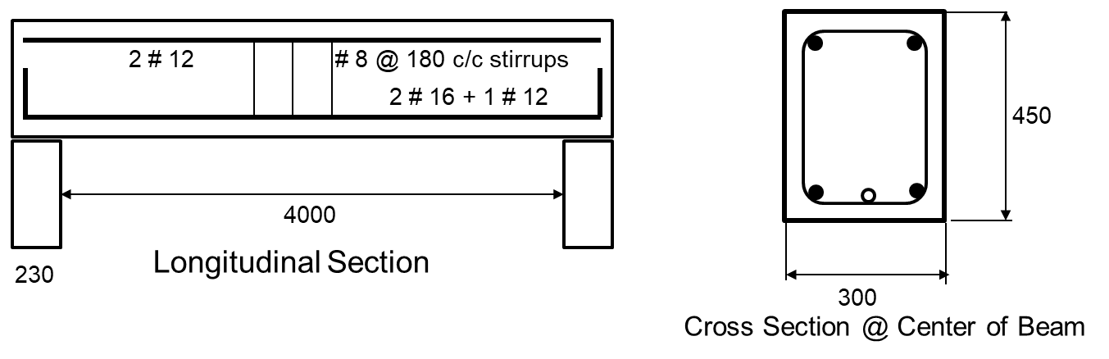

|  |  |  |
| --- | --- | --- |
| **Reinforcement** | **Blooms Designation**  AN | **Score**  **7** |

c) How would you model Class I pipes?

|  |  |  |
| --- | --- | --- |
| Pipework | **Blooms Designation**  AP | **Score**  **6** |

d) Prepare a bar bending schedule (16 # bottom reinforcement only) a RCC beam of 4m. Clear span of 300 mm width and 450mm depth. It consists of hanger bars, main longitudinal bars, and bent up bars at the bottom as shown below. Stirrups at a spacing of 180mm c/c are provided though out the length of the beam. The clear cover to the reinforcement is 40mm.



|  |  |  |
| --- | --- | --- |
| Reinforcement | **Blooms Designation**  AN | **Score**  **5** |

**TOTAL SCORE: 25 MARKS**

**Question 7**

a) What element would you choose to change the validity of a contract document?

|  |  |  |
| --- | --- | --- |
| **Legal Responsibility** | **Blooms Designation**  AP | **Score**  **7** |

b) What inference can you make: ‘standard specification prepared by the engineering department which serves as a standard guide to the department’?

|  |  |  |
| --- | --- | --- |
| **Specification** | **Blooms Designation**  AN | **Score**  **7** |

c) What could result if there is a dispute?

|  |  |  |
| --- | --- | --- |
| **Causes of Dispute** | **Blooms Designation**  AP | **Score**  **6** |

d) Can you distinguish between centering and shuttering form work?

|  |  |  |
| --- | --- | --- |
| **Concrete work** | **Blooms Designation**  AN | **Score**  **5** |

**TOTAL SCORE: 25 MARKS**

**Question 8**

a) How would you execute the estimation of steel quantities through the cubical content of the structure and type?

|  |  |  |
| --- | --- | --- |
| **Reinforcement Quantity Estimation** | **Blooms Designation**  AP | **Score**  **7** |

b) What inference can you make; ‘cost: arbitration is less expensive than court proceeding; Speed: disputes are settled much faster through arbitration as compared to law suit in the court; and convenience: arbitration hearings are fixed considering the convenience of both parties’?

|  |  |  |
| --- | --- | --- |
| **Causes and Disputes** | **Blooms Designation**  AN | **Score**  **7** |

c) What approach would you use to implement an estimate of civil works?

|  |  |  |
| --- | --- | --- |
| **Estimates** | **Blooms Designation**  AP | **Score**  **6** |

d) Can you distinguish between Drawings and specification?

|  |  |  |
| --- | --- | --- |
| **Detailed Estimates** | **Blooms Designation**  AN | **Score**  **5** |

**TOTAL SCORE: 25 MARKS**

**PART C [EVALUATING AND CREATING]**

**INSTRUCTIONS: Part C contains TWO questions. Answer ONE question.**

|  |
| --- |
|  |

**Question 9**

1. Prepare a detailed estimate of 1 meter length of 900mm U-Drain as shown in fig. 1. Earthwork in trenches only.

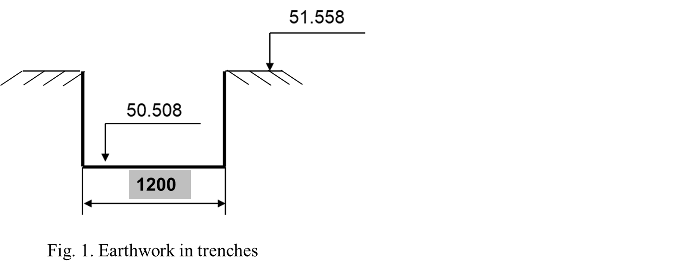

|  |  |  |
| --- | --- | --- |
| **Earthworks** | **Blooms Designation**  **CR** | **Score**  **7** |

1. The density of tor bars may be taken as 7850 kg/m3 thus, develop a model of the weight per running meter for common tor steel bars in the range of 10mm, 12mm, 16mm & 20mm diameter.

|  |  |  |
| --- | --- | --- |
| **Reinforcement Quantity Estimation** | **Blooms Designation**  **CR** | **Score**  **6** |

1. Prepare a detailed estimate of 1 meter length of 900mm U-Drain as shown in fig. 2. Fly ash cement concrete works only.

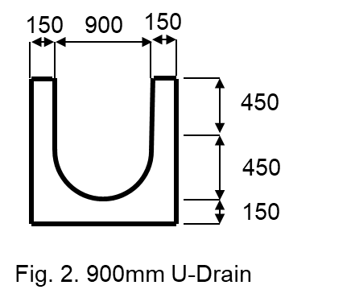

|  |  |  |
| --- | --- | --- |
| **Cement Concrete works** | **Blooms Designation**  **EV** | **Score**  **7** |

d) Develop a model of an abstract estimate of the 1meter length of the 900mm U-Drain @ a rate of $100 excavation in trenches and $1000 Fly ash cement concrete as shown in fig. 1 & 2. Ignore centering and shutting

|  |  |  |
| --- | --- | --- |
| **Abstract Estimate** | **Blooms Designation**  **EV** | **Score**  **5** |

**TOTAL SCORE: 25 MARKS**

**Question 10**

a) Prepare a detailed estimate per 1 meter length for the reinforced concrete drain with side slope 1:1, earthwork in excavation only as shown in the Fig. 3.

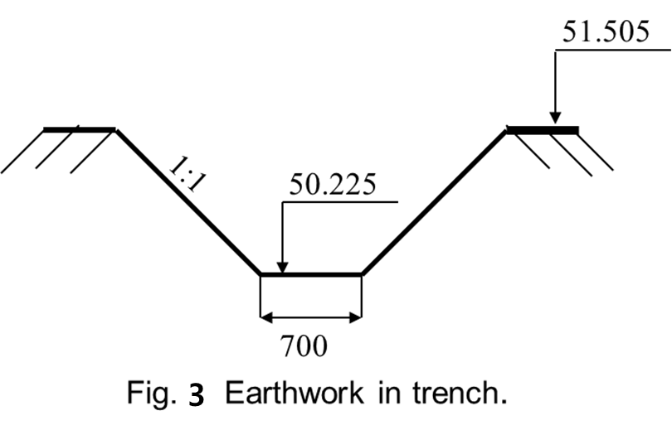

|  |  |  |
| --- | --- | --- |
| **Earthwork** | **Blooms Designation**  **EV** | **Score**  **7** |

b) Prepare a detailed estimate per 1 meter length for the reinforced concrete storm drain with side slopes 1:1 as shown in the Fig. 4. Fly ash cement concrete work only.

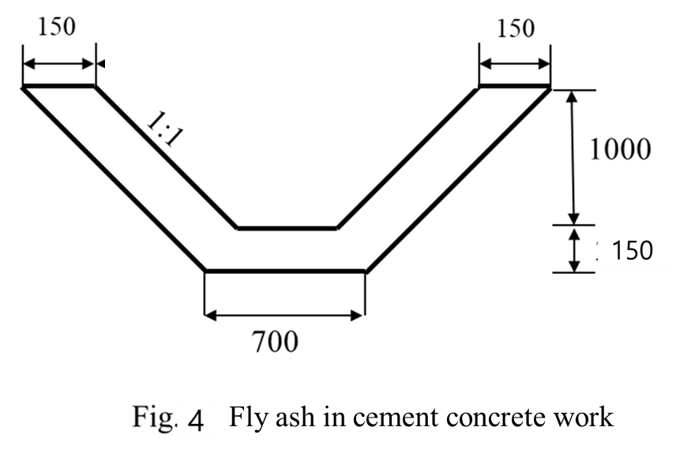

|  |  |  |
| --- | --- | --- |
| **Fly Ash Cement Concrete Works** | **Blooms Designation**  **EV** | **Score**  **7** |

c) Develop a model of an abstract estimate per meter length for the storm drain as shown in fig. 3 & 4. Earth work in trench @ $100 and Fly ash cement concrete works @ $1000. Ignore centering and shutting

|  |  |  |
| --- | --- | --- |
| **Abstract Estimate** | **Blooms Designation**  **CR** | **Score**  **6** |

d) Develop a model for the estimated weight of “d” mm diameter tor bars 10mm, 12mm, 16mm & 20mm? The density of tor bar may be taken as 7850 kg/m³?

|  |  |  |
| --- | --- | --- |
| **Reinforcement** | **Blooms Designation**  **CR** | **Score**  **5** |

**TOTAL SCORE: 25 MARKS**

**END OF QUESTION PAPER**