

**END OF SEMESTER EXAMINATIONS**

2ND SEMESTER 2022/2023 ACADEMIC YEAR

DATE: JULY 2023

**COURSE CODE: CVE 301**

**COURSE TITLE: STRUCTURAL ANALYSIS**

LECTURER NAME: ENGR. **SAMUEL WILBERFORCE OFFEI**

Duration: 3 HOURS

|  |  |  |
| --- | --- | --- |
|  | **COURSE OUTLINE(MAIN TOPICS)** | **QUESTION NO** |
| **Major Topic 1** | **Elastic constants** | **4b** |
| **Major Topic 2** | **Analysis of stress** | **PB2a,2b** |
| **Major Topic 3** | **Strain Energy** | **4a** |
| **Major Topic 4** | **Analysis of Statically Indeterminate Structures** | **3a,3b** |
| **Major Topic 5** | **Stiffness Method of Analysing Structures - Truss** | **5a** |
| **Major Topic 6** | **Impact loading** | **5b** |
| **Major Topic 7** | **Force Method of Analysing Beams** | **PB1** |
| **Major Topic 8** | **Shear force and Bending moment** | **2b** |
| **Major Topic 9** | **Geometric Properties of structural section** | **2c** |
| **Major Topic 10** | **Bending Stresses in beams** | **2a, -1c, PA-2c** |
| **Major Topic 11** | **Principle of Work and Energy** | **PA-1a,1b** |

**PART A (UNDERSTANDING)**

**INSTRUCTIONS: Part A contains FIVE questions. Answer ALL questions.**

**Questions 1**

|  |  |  |
| --- | --- | --- |
| Major Topic 5 | Blooms Designation UN | **Score 5** |

As Given: By using Area Moment Method. A fixed beam of span 6m carries UDL of 10kN/m over the entire span. Calculate the fixed end moments.

**Questions 2**

|  |  |  |
| --- | --- | --- |
| Major Topic 6 | Blooms Designation UN | **Score 5** |

Find the reaction and draw the shear force for the diagram of the beam below. FIGURE 1

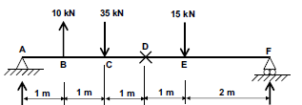

**Questions 3**

|  |  |  |
| --- | --- | --- |
| Major Topic 6 | Blooms Designation UN | **Score 5** |

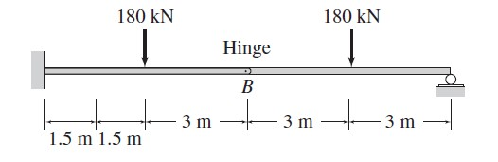

FIGURE 2 Determine the support reactions of structure above

**Questions 4**

|  |  |  |
| --- | --- | --- |
| Major Topic 10 | Blooms Designation UN | **Score 6** |

Explain the in your own word discuss the MOHR’S THEOREMS and show how it relate to beam calculation.

**Questions 5**

|  |  |  |
| --- | --- | --- |
| Major Topic 5 | Blooms Designation UN | **Score 5** |

FIGURE 3

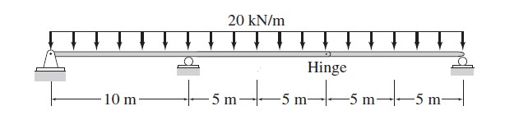

For the figure above, Name thr types of supports on the struture and draw the shear and bending moment diagrams.

**[TOTAL MARKS = 25]**

**PART B[APPLICATION AND ANALYSIS]**

**INSTRUCTIONS: Part B contains THREE questions. Attempt any TWO questions.**

**Question 6**

|  |  |  |
| --- | --- | --- |
| Major Topic 8 | Blooms Designation  **AP** | **Score 8** |

1. A square concrete column in an office building is shown below. The column has cross section of 400mm x 400mm and supports a total vertical load of 2000kN. Calculate the direct compressive stress at any point in the column. If the column reduces in length by 3.5 mm, the loading and the column’s original length was 4 meters. Calculate;
   * 1. The strain
     2. Stress
     3. Young modulus in the column.

|  |  |  |
| --- | --- | --- |
| Major Topic 11 | Blooms Designation AN | **Score 8** |

1. The structure below could be solved using statically indeterminate method. As a civil engineering student,
2. Explain the differences between statically determinate and statically indeterminate structure.

|  |  |  |
| --- | --- | --- |
| Major Topic 11 | Blooms Designation AP | **Score 8** |

1. Determine the reaction at the support for the frame showing at figure 4.

FIGURE 4

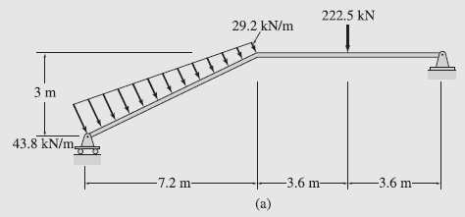

**[TOTAL MARKS = 25]**

**Question 7**

|  |  |  |
| --- | --- | --- |
| Major Topic 2 | Blooms Designation **AP** | **Score 4** |

FIGURE 5

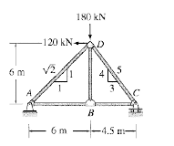

|  |  |  |
| --- | --- | --- |
| Major Topic 1 | Blooms Designation **AP** | **Score 7** |

1. State and explain the type of structure shown in the figure 5.

|  |  |  |
| --- | --- | --- |
| Major Topic 1 | Blooms Designation **AN** | **Score 7** |

1. Determine the support reactions of the structures.

|  |  |  |
| --- | --- | --- |
| Major Topic 1 | Blooms Designation **AP** | **Score 7** |

1. Using the method of join, determine the forces on each joint and comment on the signs on the forces.

**Question 8**

|  |  |  |
| --- | --- | --- |
| Major Topic 1 | Blooms Designation **AN** | **Score 7** |

1. **A** simply supported beam of hollow circular section of external diameter 200mm, and internal diameter 150mm has a span of 6m. It is subjected to concentrated load of 50kN and Udl of 5kN/m over the entire span. Determine the maximum slope at the support and maximum deflection at centre. Take E = 2 x 105 N/mm2

|  |  |  |
| --- | --- | --- |
| Major Topic 11 | Blooms Designation **AP** | **Score 7** |

Given that **EI** is constant

1. Explain the following terminology:
   * 1. The strain
     2. Stress
     3. Young modulus in the column.
     4. Rigid Prop

***A simply supported beam of hollow circular section of external diameter 200mm and internal diameter 150mm has a span of 6m. It is subjected to concentrated load of 50kN and UDL of 7kN/m over the entire span. Determine the following***

1. the reactions,

|  |  |  |
| --- | --- | --- |
| Major Topic 11 | Blooms Designation **AP** | **Score 2** |

1. the maximum slope at the support and

|  |  |  |
| --- | --- | --- |
| Major Topic 11 | Blooms Designation **AP** | **Score 3** |

1. Maximum deflection at the center. (Take E =2 x 105 N/mm2)

|  |  |  |
| --- | --- | --- |
| Major Topic 11 | Blooms Designation **AN** | **Score 3** |

1. Examine how the load distributions will occurs on structural members

|  |  |  |
| --- | --- | --- |
| Major Topic 10 | Blooms Designation **AP** | **Score 3** |

**[TOTAL MARKS = 25]**

**PART C [EVALUATING AND CREATING]**

**INSTRUCTIONS: Part C contains TWO questions. Answer ONE question.**

**Question 9**

|  |  |  |
| --- | --- | --- |
| Major Topic 8 | Blooms Designation EV | **Score 6** |

1. Explain each of the following
2. Free Body Diagram
3. Load reactions directions
4. Equilibrium reaction

|  |  |  |
| --- | --- | --- |
| Major Topic 10 | Blooms Designation CR | **Score 8** |

1. A rectangular link AB made of steel is used to support a load W through a rod CD as shown in figure 1.27. If the link AB is 30mm wide, determine its thickness for a factor of safety 2.5. The ultimate strength of steel may be assumed to be 450 MPa.

FIGURE 6



|  |  |  |
| --- | --- | --- |
| Major Topic 10 | Blooms Designation EV | **Score 14** |

FIGURE 7

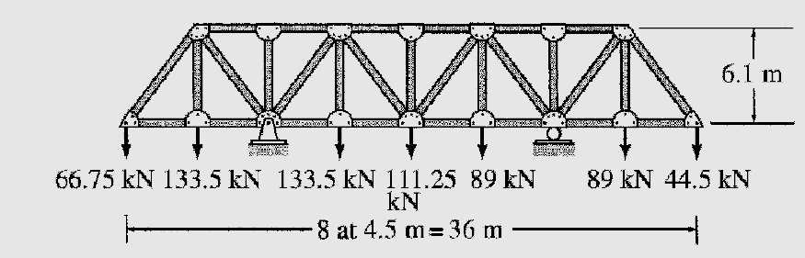

Determine the following on the structure above:

1. The type of structure above (3 marks)
2. The free-body diagrame (4 marks)
3. The determinancy of the structure (2 marks)
4. The support reactions (7 marks)

**[TOTAL MARKS = 30]**

**Question 10**

|  |  |  |
| --- | --- | --- |
| Major Topic 10 | Blooms Designation AP | **Score 8** |

1. As Given: By using Area Moment Method. A fixed beam of span 6m carries UDL of 10kN/m over the entire span. Calculate the fixed end moments. Draw the SFD and BMD. Also mark the point of contra flexure.

|  |  |  |
| --- | --- | --- |
| Major Topic 10 | Blooms Designation AP | **Score 18** |

1. Analyse the beam given in the **figure 8** below by using **moment distribution method**. (6 marks)

Hence:

1. The stiffness of the beam. (4 marks)
2. The distribution factor **DF** of the beam. (4 marks)
3. Reproce the figure below in free body diagram (4 marks)

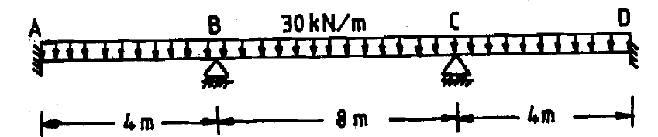

|  |  |  |
| --- | --- | --- |
| Major Topic 10 | Blooms Designation CR | **Score 4** |

1. Elaborate the advantage of propped cantilever beam

**[TOTAL MARKS = 30]**

**END OF PAPER**