

**END OF SEMESTER EXAMINATIONS**

2ND SEMESTER 2023/2024 ACADEMIC YEAR

DATE: JULY 2023

**COURSE CODE: CVE 207**

**COURSE TITLE: THEORY OF STRUCTURES**

LECTURER NAME: ENGR. **SAMUEL WILBERFORCE OFFEI**

Duration: 3 HOURS

|  |  |  |
| --- | --- | --- |
|  | **COURSE OUTLINE(MAIN TOPICS)** | **QUESTION NO** |
| **Major Topic 1** | **Elastic constants** | **4b** |
| **Major Topic 2** | **Analysis of stress** | **PB2a,2b** |
| **Major Topic 3** | **Strain Energy** | **4a** |
| **Major Topic 4** | **Analysis of Statically Indeterminate Structures** | **3a,3b** |
| **Major Topic 5** | **Stiffness Method of Analysing Structures - Truss** | **5a** |
| **Major Topic 6** | **Impact loading** | **5b** |
| **Major Topic 7** | **Force Method of Analysing Beams** | **PB1** |
| **Major Topic 8** | **Shear force and Bending moment** | **2b** |
| **Major Topic 9** | **Geometric Properties of structural section** | **2c** |
| **Major Topic 10** | **Bending Stresses in beams** | **2a, -1c, PA-2c** |
| **Major Topic 11** | **Principle of Work and Energy** | **PA-1a,1b** |

**PART A (UNDERSTANDING)**

**INSTRUCTIONS: Part A contains FIVE questions. Answer ALL questions.**

**Questions**

|  |  |  |
| --- | --- | --- |
| Major Topic 5 | Blooms Designation **AP** | **Score 5** |

1. As Given: By using Area Moment Method. A fixed beam of span 6m carries UDL of 10kN/m over the entire span. Calculate the fixed end moments.

|  |  |  |
| --- | --- | --- |
| Major Topic 6 | Blooms Designation **EV** | **Score 5** |

1. Find the reaction and draw the shear force for the diagram of the beam below.

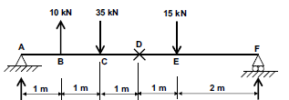

|  |  |  |
| --- | --- | --- |
| Major Topic 6 | Blooms Designation **AP** | **Score 5** |

1. Discuss your answer based on the solution **a** above.

|  |  |  |
| --- | --- | --- |
| Major Topic 10 | Blooms Designation  **UN** | **Score 6** |

1. Explain the in your own word discuss the MOHR’S THEOREMS and show how it relate to beam calculation.

|  |  |  |
| --- | --- | --- |
| Major Topic 5 | Blooms Designation **K** | **Score 5** |

1. With an aid of a well labeled diagram, draw a simply supported beam with length 12cm and depth and breath 400mm and it should draw to scale.

**[TOTAL MARKS = 25]**

**PART B [APPLICATION AND ANALYSIS]**

**INSTRUCTIONS: Part B contains THREE questions. Attempt any TWO questions.**

**Question 6**

|  |  |  |
| --- | --- | --- |
| Major Topic 8 | Blooms Designation  **AP** | **Score 7** |

1. A square concrete column in an office building is shown below. The column has cross section of 400mm x 400mm and supports a total vertical load of 2000kN. Calculate the direct compressive stress at any point in the column. If the column reduces in length by 3.5 mm, the loading and the column’s original length was 4 meters. Calculate;
   * 1. The strain
     2. Stress
     3. Young modulus in the column.

|  |  |  |
| --- | --- | --- |
| Major Topic 11 | Blooms Designation **K** | **Score 6** |

1. Explain the effect of the load on the column below hence the volume.



|  |  |  |
| --- | --- | --- |
| Major Topic 4 | Blooms Designation **UN** | **Score 8** |

1. A member ABCD is subjected to a point loads P1, P2, P3 and P4 as shown in figure 3.1 below.

***figure 3.1***

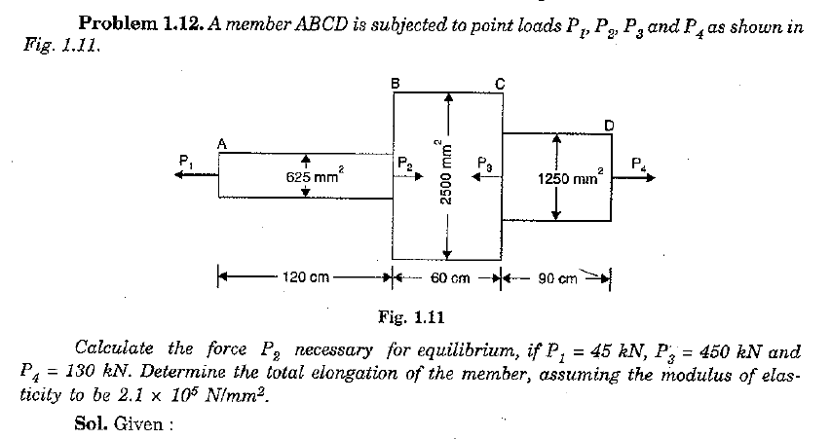

Calculate the force P2 necessary for equilibrium, if P1 = 45kN, P3 = 450kN and P4 =130kN. Determine the total elengation of the member, assuming the modulus of elasticity to be 2.1x105 N/mm2.

|  |  |  |
| --- | --- | --- |
| Major Topic 2 | Blooms Designation **K** | **Score 4** |

1. Explain the above calculation. **[TOTAL MARKS = 25]**

**Question 7**

|  |  |  |
| --- | --- | --- |
| Major Topic 2 | Blooms Designation **K** | **Score 4** |

1. Explain the term contra flexural load in beams.

|  |  |  |
| --- | --- | --- |
| Major Topic 1 | Blooms Designation **UN** | **Score 5** |

1. State and explain the merit and demerit of fixed end structural member beam.

|  |  |  |
| --- | --- | --- |
| Major Topic 1 | Blooms Designation **UN** | **Score 8** |

1. **A** simply supported beam of hollow circular section of external diameter 200mm, and internal diameter 150mm has a span of 6m. It is subjected to concentrated load of 50kN and Udl of 5kN/m over the entire span. Determine the maximum slope at the support and maximum deflection at centre. Take E = 2 x 105 N/mm2

|  |  |  |
| --- | --- | --- |
| Major Topic 1 | Blooms Designation **UN** | **Score 8** |

1. A rectangular beam 300 mm deep is simply supported over a span of 4 meters. Determine the uniformly distributed load per meter which the beam may carry, if the bending stress should not exceed 120 N/mm2. Take I = 8 x106 mm4.

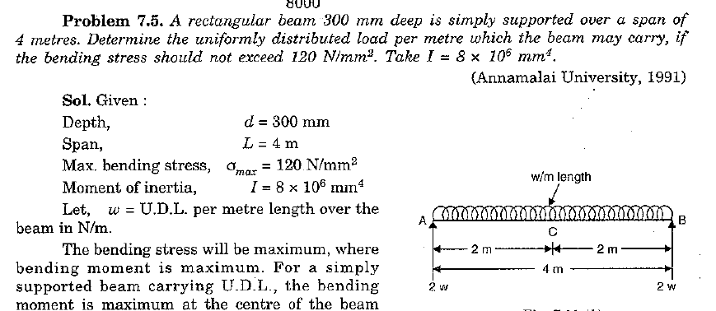

**[TOTAL MARKS = 25]**

**PART B**

**TWO QUESTIONS ANSWER ONLY ONE**

**Question 8**

|  |  |  |
| --- | --- | --- |
| Major Topic 11 | Blooms Designation **AP** | **Score 7** |

Given that **EI** is constant

1. Explain the following terminology:
   * 1. The strain
     2. Stress
     3. Young modulus in the column.
     4. Rigid Prop

*A simply supported beam of hollow circular section of external diameter 200mm and internal diameter 150mm has a span of 6m. It is subjected to concentrated load of 50kN and UDL of 7kN/m over the entire span. Determine the following*

1. the reactions,

|  |  |  |
| --- | --- | --- |
| Major Topic 11 | Blooms Designation **AP** | **Score 2** |

1. the maximum slope at the support and

|  |  |  |
| --- | --- | --- |
| Major Topic 11 | Blooms Designation **AP** | **Score 3** |

1. maximum deflection at the center. (Take E =2 x 105 N/mm2)

|  |  |  |
| --- | --- | --- |
| Major Topic 11 | Blooms Designation **UN** | **Score 3** |

1. Examine how the load distributions will occurs on structural members

|  |  |  |
| --- | --- | --- |
| Major Topic 10 | Blooms Designation **AP** | **Score 3** |

1. As structural engineer, explain the differences in Area moment method, Mohr’s theorem I and Mohr’s theorem II.

|  |  |  |
| --- | --- | --- |
| Major Topic 11 | Blooms Designation **K** | **Score 7** |

**[TOTAL MARKS = 25]**

**PART C [EVALUATING AND CREATING]**

**INSTRUCTIONS: Part C contains TWO questions. Answer ONE question.**

**Question 9**

|  |  |  |
| --- | --- | --- |
| Major Topic 8 | Blooms Designation AP | **Score 4** |

1. With the aid of a well labeled diagram, state five (5) different type of beams and column.

|  |  |  |
| --- | --- | --- |
| Major Topic 8 | Blooms Designation AP | **Score 8** |

1. Explain each of the following
2. Free Body Diagram
3. Load reactions directions
4. Equilibrium reaction

|  |  |  |
| --- | --- | --- |
| Major Topic 10 | Blooms Designation K | **Score 6** |

1. Calculate the **Reaction** by determine the load on the beams and explain the engineering strength that needed to be taken care of in the process of design.

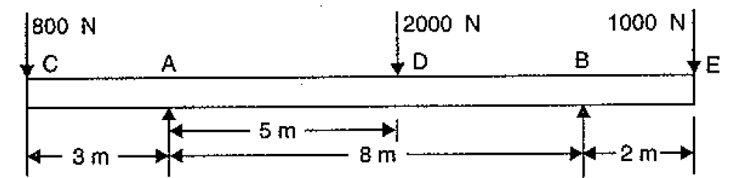

***Figure 2.1***

|  |  |  |
| --- | --- | --- |
| Major Topic 10 | Blooms Designation UN | **Score 7** |

1. A Simply supported beam of span 6m is subjected to two point loads of 50kN each at midthird point in addition to Udl of 5kN/m throughout the length. Calculate the maximum slope and the maximum deflection in the beam. Take EI = 200 x 102 kN/m2

**[TOTAL MARKS = 25]**

**Question 10**

|  |  |  |
| --- | --- | --- |
| Major Topic 10 | Blooms Designation AP | **Score 8** |

1. As Given: By using Area Moment Method. A fixed beam of span 6m carries UDL of 10kN/m over the entire span. Calculate the fixed end moments. Draw the SFD and BMD. Also mark the point of countra flexure.

|  |  |  |
| --- | --- | --- |
| Major Topic 10 | Blooms Designation AP | **Score 6** |

1. Calculate the **Reaction** by determine the load on the beams and explain the engineering strength that needed to be taken care of in the process of design.



|  |  |  |
| --- | --- | --- |
| Major Topic 10 | Blooms Designation K | **Score 6** |

1. Outline the **SIX(6)** method used in the determination of **INDETERMINATE BEAM**

|  |  |  |
| --- | --- | --- |
| Major Topic 10 | Blooms Designation K | **Score 5** |

1. Elaborate the advantage of propped cantilever beam

**END OF PAPER**