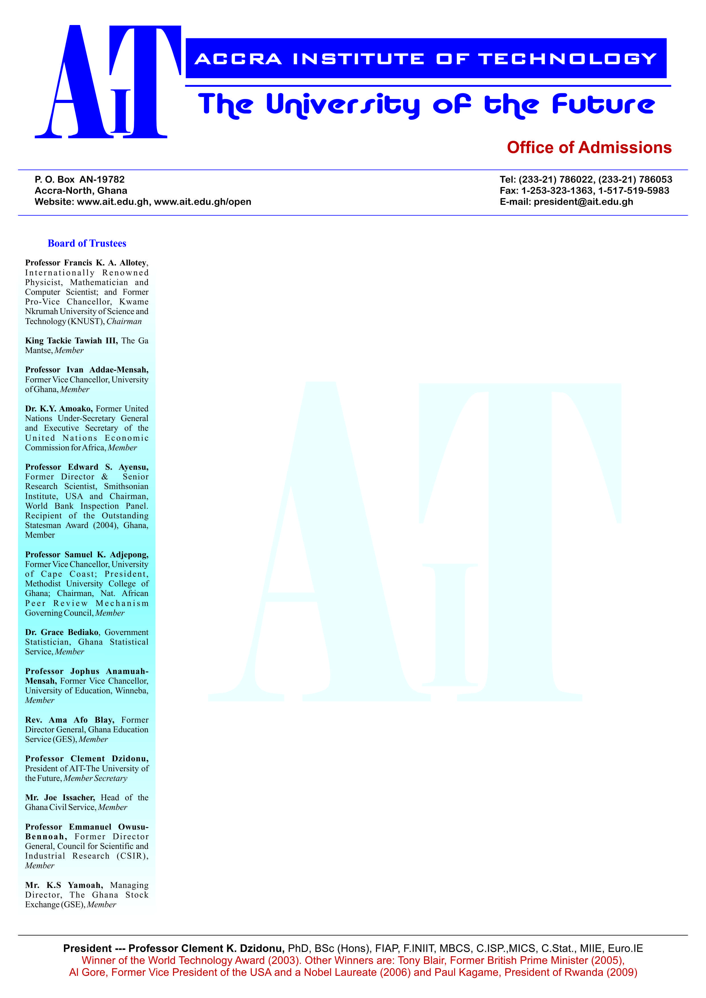

**END OF SEMESTER EXAMINATIONS**

2ND SEMESTER 2022/2023 ACADEMIC YEAR

DATE: JULY 2023

**COURSE CODE: CVE103**

**COURSE TITLE:** ELEMENTARY STRUCTURES

**LECTURER’S NAME: SAMUEL WILBERFORCE OFFEI**

**DURATION: 3 HOURS**

|  |  |  |
| --- | --- | --- |
|  | **COURSE OUTLINE (MAIN TOPICS)** | |
| **MajorTopic-1** | Free body diagram | 1b |
| **MajorTopic-2** | Normal, shear and bearing stress |  |
| **MajorTopic-3** | Stress on inclined plains under axial loading | 1a |
| **MajorTopic-4** | Train | 2a, 4b |
| **MajorTopic-5** | Mechanical properties of materials | 5a |
| **MajorTopic-6** | True stress and true strain | 3a, 3b |
| **MajorTopic-7** | Poissions ratio | 3c, 4a, 4c |
| **MajorTopic-8** | Elasticity and plasticity | 1c, 5c |
| **MajorTopic-9** | Deformation in axially loaded members | 6a |
| **MajorTopic-10** | Thermal effect in a structural member | 6b |
| **MajorTopic-11** | Design consideration | 2b |
| **MajorTopic-12** | Strain energy | 6c |
| **MajorTopic-13** | Impact loading | 5c |

**FOUR QUESTIONS ANSWER THREE**

**Questions**

|  |  |  |
| --- | --- | --- |
| Major Topic 3 | Blooms Designation **AP** | **Score 5** |

1. A Structural analysis is an integral part of any structural engineering project, its function being the prediction of the performance of the proposed structure. List five element of a structural members.
2. A steel tube with an inside diameter of 100 mm is to carry a tensile load of 400 kN. Determine the stress in the tube with the help of a well labeled diagram leave your answer in MN/m2.

|  |  |  |
| --- | --- | --- |
| Major Topic 1 | Blooms Designation **CR** | **Score 5** |

1. Differentiate the purpose of Plinth and Lintel in a reinforce concrete building

|  |  |  |
| --- | --- | --- |
| Major Topic 8 | Blooms Designation **AP** | **Score 5** |

1. Explain the formula below.

|  |  |  |
| --- | --- | --- |
| Major Topic 4 | Blooms Designation **AP** | **Score 5** |

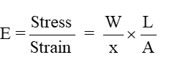

1. Foundation is one of the most important part of the building. Building activity starts with digging the ground for foundation and then building on it. State the main functions of it.

|  |  |  |
| --- | --- | --- |
| Major Topic 6 | Blooms Designation **AP** | **Score 5** |

**TOTAL SCORE: 25 MARKS**

**Question 6.**

1. Find the diameter of a circular bar which is subjected to an axial pull of 160kN, if the maximum allowable shear stress on any section is 65N/mm2.

|  |  |  |
| --- | --- | --- |
| Major Topic 7 | Blooms Designation **AP** | **Score 5** |

1. Throughout the analysis of pin-jointed frames using the method of resolution of joints, there are three rules to remember of which it has been taught as stated below write a short notes by explain them
2. ***Rule No. 1: Force acts in same direction as member***
3. ***Rule No. 2: Equilibrium applies everywhere***

|  |  |  |
| --- | --- | --- |
| Major Topic 8 | Blooms Designation **AP** | **Score 5** |

1. Discuss the element that can be found at superstructure of a building.

|  |  |  |
| --- | --- | --- |
| Major Topic 7 | Blooms Designation **AP** | **Score 5** |

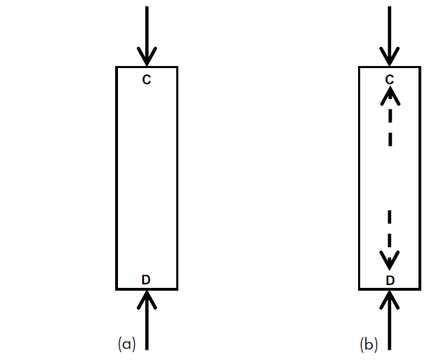

1. Comment on the diagram shown above

|  |  |  |
| --- | --- | --- |
| Major Topic 7 | Blooms Designation **AP** | **Score 4** |

1. A tensile test was conducted on a mild steel bar. The following data was obtained from the test:

Data: (i) Diameter of the steel bar = 3cm

(ii) Gauge Length of the bar = 20cm

(iii) load at elastic limite = 250kN

(iv) Extension at a load of 150 kN = 0.21mm

(v) Maximum Load = 380kN

(vi) Total extension = 60mm

(vii) Diameter of the rod at the failure = 2.25cm

Determine:

(a) The Young’s modulus

(b) The tress at elastic limit

(c) The percentage elongation

|  |  |  |
| --- | --- | --- |
| Major Topic 3 | Blooms Designation **CR** | **Score 6** |

**[TOTAL MARKS = 25]**

**QUESTION 7**

|  |  |  |
| --- | --- | --- |
| Major Topic 4 | Blooms Designation **CR** | **Score 5** |

1. Explain the figure below as it shown 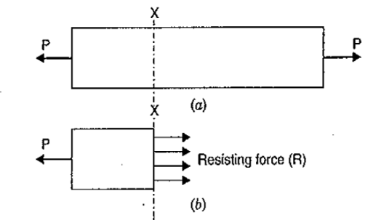

|  |  |  |
| --- | --- | --- |
| Major Topic 13 | Blooms Designation **CR** | **Score 5** |

1. In the diagram below find the reaction of the structure.

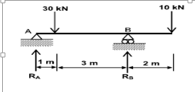

|  |  |  |
| --- | --- | --- |
| Major Topic 8 | Blooms Designation **AP** | **Score 6** |

1. The total tensile load and uitimate load stress for a hollow steel column which carries an axial load of 2.0 MN is 489 N/mm2. If it has been given an external coloum diameter of 225mm, determine the internal diameter. Take the factor of safety a 4.5.

|  |  |  |
| --- | --- | --- |
| Major Topic 9 | Blooms Designation **CR** | **Score 6** |

1. By way of explaining the words on the diagram, comment on the differences between them.



|  |  |  |
| --- | --- | --- |
| Major Topic 12 | Blooms Designation **CR** | **Score 3** |

**TOTAL SCORE: 25 MARKS**

**QUESTION 8**

1. In your own words explain the differences between compression and tension with a diagram

|  |  |  |
| --- | --- | --- |
| Major Topic 12 | Blooms Designation **AP** | **Score 6** |

1. Simple explain the differences between, Load bearing wall and structural Partition wall

|  |  |  |
| --- | --- | --- |
| Major Topic 8 | Blooms Designation **AP** | **Score 6** |

1. State and explain the types of slabs in structural design arena.

|  |  |  |
| --- | --- | --- |
| Major Topic 3 | Blooms Designation **AP** | **Score 6** |

1. A rod 150cm long and of diameter 2.0 cm is subjected to an axial pull of 20kN. If the modulus of elasticity of the materials of the rod is 2 x 105 N/mm2; determine:
2. The stress
3. The strain, and
4. The elongation.

|  |  |  |
| --- | --- | --- |
| Major Topic 8 | Blooms Designation **AP** | **Score 7** |

**TOTAL SCORE: 25 MARKS**

**PART C [EVALUATING AND CREATING]**

**INSTRUCTIONS: Part C contains TWO questions. Answer ONE question.**

**QUESTION 9**

1. With an aid of a diagram explain the differences between the three types of supports

|  |  |  |
| --- | --- | --- |
| Major Topic 8 | Blooms Designation **AP** | **Score 8** |

1. Find the minimum diameter of a steel of load 230*N*, the Stress is 2x105*N/mm2*

|  |  |  |
| --- | --- | --- |
| Major Topic 12 | Blooms Designation **AP** | **Score 7** |

1. Column and Beam

|  |  |  |
| --- | --- | --- |
| Major Topic 5 | Blooms Designation **AP** | **Score 6** |

1. Find the Young’s Modulus of a brass rod of diameter *25mm* and of length 250*mm* which is subjected to a tensile load of *50 kN* when the extension of the rod is equal to *0.3mm*.

|  |  |  |
| --- | --- | --- |
| Major Topic 8 | Blooms Designation **AP** | **Score 9** |

**TOTAL SCORE: 30 MARKS**

**QUESTION 10**

1. With an aid of a diagram explain the types of load ii civil engineering arena

|  |  |  |
| --- | --- | --- |
| Major Topic 3 | Blooms Designation **AP** | **Score 7** |

1. Explain Young’s modulus of a structure steel and how is it important to know

|  |  |  |
| --- | --- | --- |
| Major Topic 12 | Blooms Designation **AP** | **Score 7** |

1. State and explain Hook’s Law

|  |  |  |
| --- | --- | --- |
| Major Topic 5 | Blooms Designation **AP** | **Score 7** |

1. Find the Young’s Modulus of a Aluminum rod of diameter *60 mm* and of length 230*mm* which is subjected to a tensile load of 2*50 kN* when the extension of the rod is equal to *1cm*.

|  |  |  |
| --- | --- | --- |
| Major Topic 8 | Blooms Designation **AP** | **Score 9** |

**TOTAL SCORE: 30 MARKS**

**[END OF PAPER]**