

END OF SEMESTER EXAMINATION

**2ND SEMESTER 2022/2023 ACADEMIC YEAR**

DATE: JULY 2023

**COURSE CODE: CVE 543**

**COURSE TITLE: ADVANCED STRUCTURAL ANALYSIS**

LECTURER NAME: ING ANDREWS OPPONG-APPIAH

Duration: 3 HOURS

|  |  |  |
| --- | --- | --- |
|  | **COURSE OUTLINE(MAIN TOPICS)** | **QUESTION NO** |
| **Major Topic 1 Sub Topic 1.1 Sub Topic 1.2 Sub Topic 1.3 Sub Topic 1.4** | **Cable and Arches Cables Cable Subjected to Concentrated Loads Arches Three-Hinged Arch** | **Q4A Q4B  Q4C  Q4D** |
| **Major Topic 2 Sub Topic 2.1** | **Influence Lines for Statically Determinate Structures Influence lines for Beams** | **Q3A Q3B** |
| **Major Topic 3 Sub Topic 3.1 Sub Topic 3.2 Sub Topic 3.3 Sub Topic 3.4** | **Deflections Using Energy Method Principle of Work and Energy Principle of Virtual Work Method of Virtual Work: Truss Method of Virtual Work: Beams and Frames** | **Q1A Q1B Q1C** |
| **Major Topic 4 Sub Topic 4.1 Sub Topic 4.2** | **Analysis of Statically Indeterminate Structures by Force Method Statically Indeterminate structures Force Method of Analysing Beams** | **Q5A Q5B Q5C** |
| **Major Topic 5 Sub Topic 5.1 Sub Topic 5.2 Sub Topic 5.3 Sub Topic 5.4 Sub Topic 5.5** | **Stiffness Method of Analysing Structures Member Stiffness Matrix Displacement and Force Transformation Member Global Stiffness Matrix Truss Stiffness Matrix Application of the Stiffness Method for Truss Analysis** | **Q2A Q2B Q2C Q2D** |

**Part A**

**Answer all questions**

|  |
| --- |
|  |

**Question 1**

1. What is an influence line of a moving object?

|  |  |  |
| --- | --- | --- |
| **Major topic - Influence Lines for Statically Determinate Structures** | **UN** | **5** |

1. Explain the term statically determinate structure.

|  |  |  |
| --- | --- | --- |
| **Major topic -Deflections using Energy Method** | **UN** | **5** |

1. Discuss the difference between cable and arches.

|  |  |  |
| --- | --- | --- |
| **Major topic - Cable and Arches** | **UN** | **5** |

1. Can some members of a truss structure be replaced with cables?

Justify your answer

|  |  |  |
| --- | --- | --- |
| **Major topic -Method of Virtual work: Truss** | **UN** | **5** |

**TOTAL [20 MARKS]**

**Question 2**

1. Explain the principle of virtual work?

|  |  |  |
| --- | --- | --- |
| **Major topic -Deflections using Energy Method** | **CR** | **6** |

1. Atrus**s** bridge has a concentrated load as shown below. As an Engineer

use the principle of virtual work to find the vertical displacement at the node C.

Take E = 200 GPa and A=400 mm2

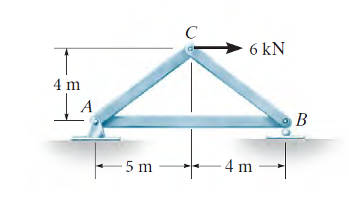

|  |  |  |
| --- | --- | --- |
| **Major topic -Deflections using Energy Method** | **AP** | **7** |

1. A steel beam is mounted on a wall with a concentrated load at the free end. As an engineer,

find the slope at the node B as shown below using virtual work.

Take E = 200 GPa and I = 60(106) mm4

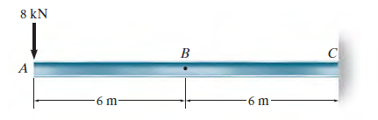

|  |  |  |
| --- | --- | --- |
| **Major topic -Deflections using Energy Method** | **AP** | **7** |

**TOTAL [20 MARKS]**

**Question 3**

A truss structure as shown below needs to be analyzed. It was studied that stiffness method is most suitable. The Area is 400 mm 2 and Modulus of elasticity of 70Gpa. The members have a constant EA, As an engineer,

1. Find the members stiffness

|  |  |  |
| --- | --- | --- |
| **Major topic - Stiffness Method of Analysing Structures** | **AP** | **6** |

1. Determine the global stiffness Matrix

|  |  |  |
| --- | --- | --- |
| **Major topic - Stiffness Method of Analysing Structures** | **EV** | **7** |

1. Find the displacements at the nodes.

|  |  |  |
| --- | --- | --- |
| **Major topic - Stiffness Method of Analysing Structures** | **AP** | **7** |

1. Find the reactions at the supports.

|  |  |  |
| --- | --- | --- |
| **Major topic - Stiffness Method of Analysing Structures** | **AN** | **7** |

400 kN

800 kN

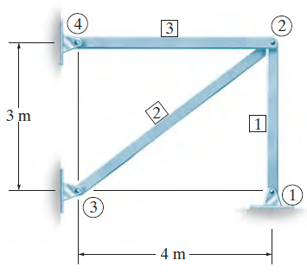

**TOTAL [20MARKS]**

**Question 4**

A moving vehicle traverse on a bridge supported by the beam below.

1. Construct the influence line for the **shear** at the point C of the beam using a step of two.

|  |  |  |
| --- | --- | --- |
| **Major topic - Influence Lines for Statically Determinate Structures** | **AP** | **7** |

1. Write the equations of the influence lines.

|  |  |  |
| --- | --- | --- |
| **Major topic - Influence Lines for Statically Determinate Structures** | **EV** | **7** |

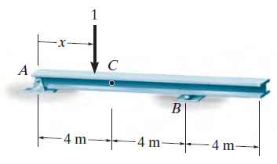

**TOTAL [14MARKS]**

**Question 5**

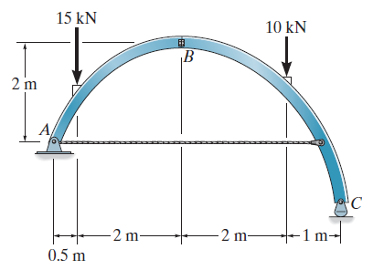

The tied three-hinge arch is subjected to the load shown below. As an engineer,

1. Determine the component of reactions at A and C.

|  |  |  |
| --- | --- | --- |
| **Major topic - Cable and Arches** | **AP** | **7** |

1. Compute the tension in the cable.

|  |  |  |
| --- | --- | --- |
| **Major topic - Cable and Arches** | **EV** | **5** |

**TOTAL [12MARKS]**

**Part B**

**Answer Two questions**

|  |
| --- |
|  |

**Question 6**

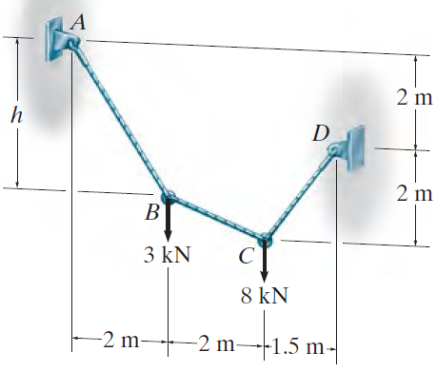

A cable supports a concentrated load as shown above. As an Engineer, compute

1. The tension in cable AB

|  |  |  |
| --- | --- | --- |
| **Major topic - Cable and Arches** | **AP** | **5** |

1. Tension in cable BC

|  |  |  |
| --- | --- | --- |
| **Major topic - Cable and Arches** | **EV** | **5** |

1. Tension in cable CD

|  |  |  |
| --- | --- | --- |
| **Major topic - Cable and Arches** | **AN** | **5** |

1. Find the distance h

|  |  |  |
| --- | --- | --- |
| **Major topic - Cable and Arches** | **AP** | **5** |

**TOTAL [20MARKS]**

**Question 7**

A statically indeterminate steel beams is shown below. As an Engineer, find

1. the reaction at the roller support using force method (Flexibility Method). Take EI Constant.

|  |  |  |
| --- | --- | --- |
| **Major topic - Analysis of Statically Indeterminate Structures by Force Method** | **AP** | **7** |

1. Draw the shear Force diagram of the beam.

|  |  |  |
| --- | --- | --- |
| **Major topic - Analysis of Statically Indeterminate Structures by Force Method** | **EV** | **6** |

1. Draw the Bending Moment diagram of the beam.

|  |  |  |
| --- | --- | --- |
| **Major topic - Analysis of Statically Indeterminate Structures by Force Method** | **AV** | **6** |

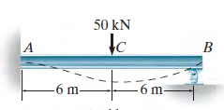

**TOTAL [20MARKS]**

**Question 8**

Hint: Break at point A

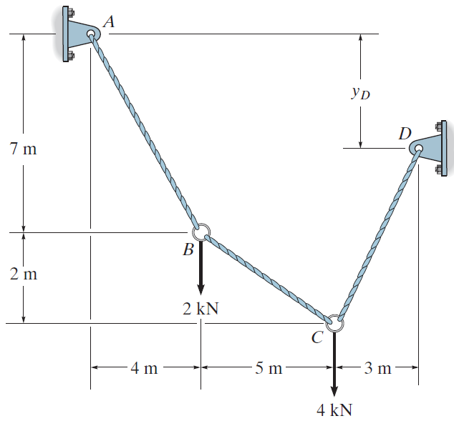

A cable supports a concentrated load as shown above. As an Engineer, compute

1. The tension in cable AB

|  |  |  |
| --- | --- | --- |
| **Major topic - Cable and Arches** | **AP** | **5** |

1. Tension in cable BC

|  |  |  |
| --- | --- | --- |
| **Major topic - Cable and Arches** | **EV** | **5** |

1. Tension in cable CD

|  |  |  |
| --- | --- | --- |
| **Major topic - Cable and Arches** | **AN** | **5** |

1. Find the distance yD

|  |  |  |
| --- | --- | --- |
| **Major topic - Cable and Arches** | **AP** | **5** |

**TOTAL [20MARKS]**