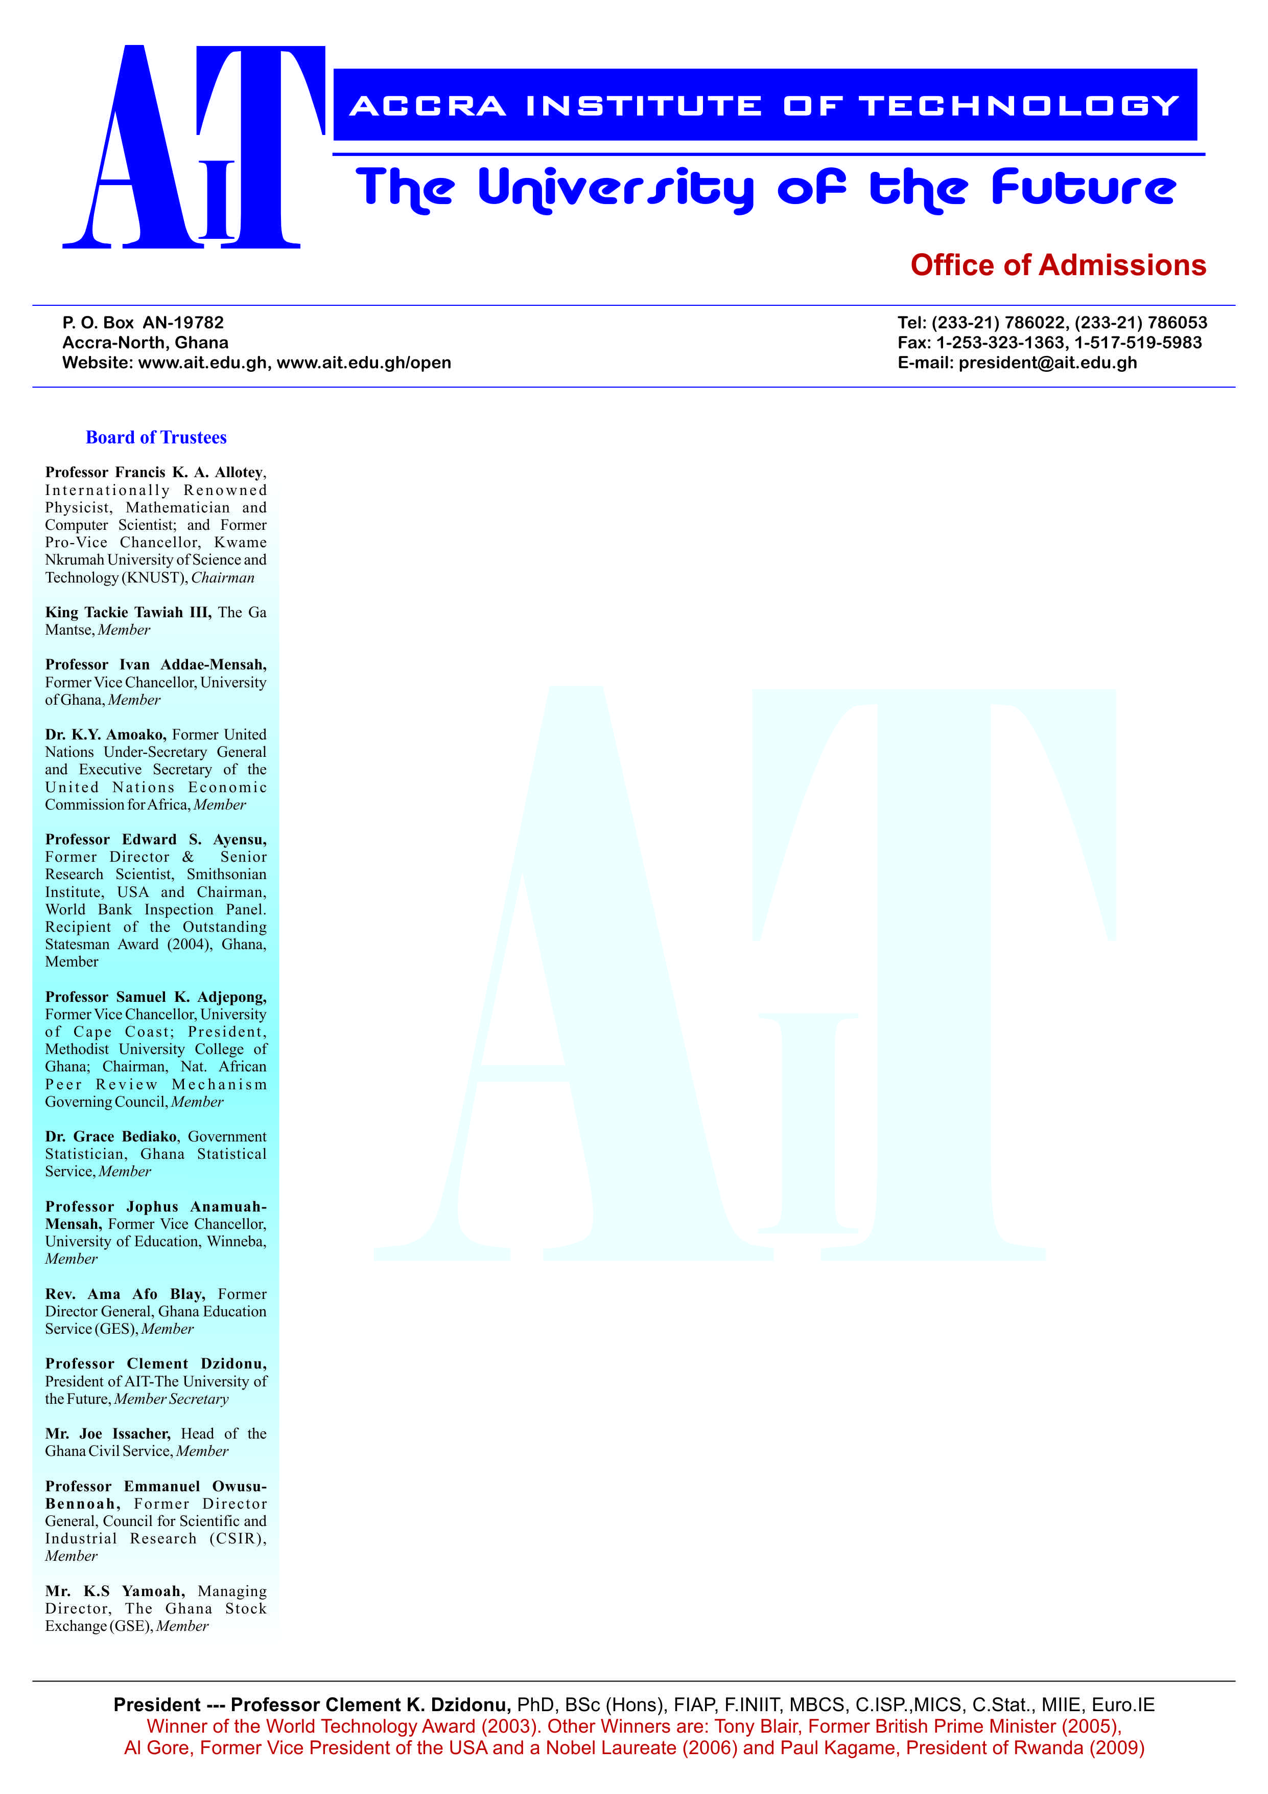

**END OF SEMESTER EXAMINATIONS**

2ND SEMESTER 2022/2023 ACADEMIC YEAR

DATE: JULY 2023

**COURSE CODE: CE 301**

**COURSE TITLE: ELECTRONIC DEVICES AND CIRCUITS**

**LECTURER’S NAME: DR. MAHAMUDA ALHAJI MAHAMADU DURATION: 3 HOURS**

**APPENDICES**

|  |  |  |
| --- | --- | --- |
|  | **COURSE OUTLINE**  **(MAIN TOPICS)** | **QUESTION NO.** |
| **MajorTopic-1** | **PN Junction Diode** | **1,6a, 7c, 7d, 9d, 10d** |
| **MajorTopic-2** | **Intrinsic and Extrinsic Semiconductors** | **6b, 8c** |
| **MajorTopic-3** | **Electronic Circuit** | **5, 7b,9b, 10b,** |
| **MajorTopic-4** | **Semiconductor devices** | **6d, 10d** |
| **MajorTopic-5** | **Diodes and Applications of Diodes** | **3,6c, 9a, 10a** |
| **MajorTopic-6** | **Bipolar Junction Transistors** | **2, 4, 8d,9c, 10c** |
| **MajorTopic-7** | **Transistor Biasing and Stabilization** | **8a** |
| **MajorTopic-8** | **Field Effect Transistors** | **7a, 8b** |

**PART A (UNDERSTANDING)**

**INSTRUCTIONS: Part A contains FIVE questions. Answer ALL questions.**

**Questions**

1. Based on the electrical conductivity all the materials in nature are classified as insulators, semiconductors, and conductors. In your own words explain why PN junction diodes are made from semiconductor materials.

|  |  |  |
| --- | --- | --- |
| Major Topic  PN Junction Diode | Blooms Designation  UN | Score  5 |

2. Intrinsic semiconductor has very limited applications as they conduct very small amounts of current at room temperature. The current conduction capability of intrinsic semiconductor can be increased significantly by adding a small amounts impurity to the intrinsic semiconductor. By adding impurities it becomes impure or extrinsic semiconductor. This process of adding impurities is called as doping. With the aid of a diagram, explain how the N-type extrinsic semiconductor is formed.

|  |  |  |
| --- | --- | --- |
| Major Topic  Principles of Semiconductor Devices | Blooms Designation  UN | Score  5 |

3. Write briefly on how the reverse breakdown voltage of a diode may decrease with increasing temperature?

|  |  |  |
| --- | --- | --- |
| Major Topic  Diodes and Applications of Diodes | Blooms Designation  UN | Score  5 |

4. In a tabular format, compare the P channel and the N channel JFET

|  |  |  |
| --- | --- | --- |
| Major Topic  FET Transistors | Blooms Designation  UN | Score  5 |

**5.** Find the power delivered to an element at t=20ms if the current i=50cost50пt A and the voltage v=2i V

|  |  |  |
| --- | --- | --- |
| Major Topic  Electronic Circuit | Blooms Designation  UN | Score.  5 |

**TOTAL SCORE: 25 MARKS**

**PART B[APPLICATION AND ANALYSIS]**

**INSTRUCTIONS: Part B contains THREE questions. Attempt any TWO questions.**

|  |
| --- |
|  |

**Question 6.**

a) With the aid of a diagram explain what happens when a PN Junction diode is **reversed** biased.

|  |  |  |
| --- | --- | --- |
| Major Topic  PN Junction Diode | Blooms Designation  AP | Score  7 |

b) In n-type Ge, the donor concentration corresponds to 1 atom per 107 Ge atoms. Assume that the effective mass to the electron equals one-half of the true mass. At room temperature, how far from the edge of the conduction band is the Fermi level?

|  |  |  |
| --- | --- | --- |
| Major Topic  Intrinsic and Extrinsic Semiconductors | Blooms Designation  AN | Score  7 |

c) In Fig. 1, the silicon controlled rectifier (SCR) has a trigger voltage of 0.7 V. Calculate the supply voltage that turns on the crowbar. Ignore zener diode resistance**.**  Fig. 1

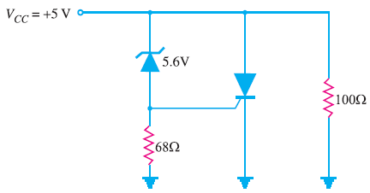

|  |  |  |
| --- | --- | --- |
| Major Topic  Diodes and Applications of Diodes | Blooms Designation  AP | Score  6 |

d) With the aid of a diagram explain the mechanism by which an electron contributes to conductivity in a semiconductor material such silicon

|  |  |  |
| --- | --- | --- |
| Major Topic  Semiconductor devices | Blooms Designation  AN | Score  5 |

**TOTAL SCORE: 25 MARKS**

**Question 7**

1. For the JFET in Fig. 2, find VDS and VGS, given that ID = 5 mA

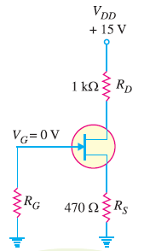

Fig. 2

|  |  |  |
| --- | --- | --- |
| Major Topic  Field Effect Transistors | Blooms Designation  AP | Score  7 |

1. For the series voltage regulator shown in Fig.3, calculate (i) output voltage and (ii) Zener current.

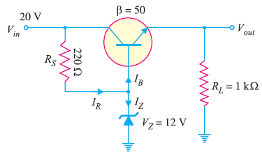

Fig. 3

|  |  |  |
| --- | --- | --- |
| Major Topic  Electronic Circuits | Blooms Designation  AN | Score  7 |

c) Compute and sketch the room temperature characteristics for a PN silicon junction with the following characteristics. W=10-3 cm, NA=1 x 1019/cm3, ND=2 x 1016/cm3, A=10-4 cm2. Assume that: Dh=8cm2/sec, De=25cm2/sec, ni=1.0 x 1010/cm3

|  |  |  |
| --- | --- | --- |
| Major Topic  PN junction Diode | Blooms Designation  AP | Score  6 |

d) In your own word explain why silicon preferred to germanium in the manufacturing of semiconductor devices such as a PN Junction Diode?

|  |  |  |
| --- | --- | --- |
| Major Topic  PN Junction Diode | Blooms Designation  AN | Score  5 |

**TOTAL SCORE: 25 MARKS**

**Question 8**

1. A base bias circuit in Fig. 4 is subjected to an increase in temperature from 25°C to 75°C. If β = 100 at 25°C and 150 at 75°C, determine the percentage change in Q-point values ( VCE and IC) over this temperature range. Neglect any change in VBE and the effects of any leakage current.

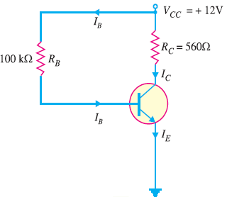

Fig 4

|  |  |  |
| --- | --- | --- |
| Major Topic  Transistor Biasing and Stabilization | Blooms Designation  AP | Score  7 |

b) **In Fig. 5, an n-channel JFET biased by potential divider method, it is desired to set the operating point at ID = 2.5 mA and VDS = 8V. If VDD = 30 V, R1 = 1 MΩ and R2 = 500 kΩ, find the value of RS. The parameters of JFET are IDSS = 10 mA and VGS (off) = – 5 V.**  Fig 5

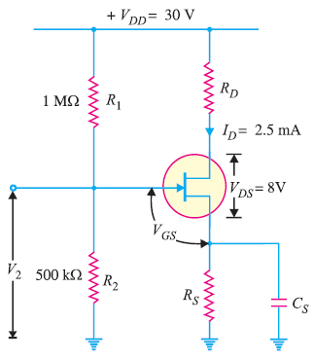

|  |  |  |
| --- | --- | --- |
| Major Topic  Field Effect Transistors | Blooms Designation  AN | Score  7 |

c) With the aid of a diagram describe how the **p-type** extrinsic semiconductor is formed

|  |  |  |
| --- | --- | --- |
| Major Topic  Intrinsic and Extrinsic Semiconductors | Blooms Designation  AP | Score  6 |

d) Explain the operations of the BJT as a Switch

|  |  |  |
| --- | --- | --- |
| Major Topic  Bipolar Junction Transistor | Blooms Designation  AN | Score  5 |

**TOTAL SCORE: 25 MARKS**

**PART C [EVALUATING AND CREATING]**

**INSTRUCTIONS: Part C contains TWO questions. Answer ONE question.**

|  |
| --- |
|  |

**Question 9**

1. The bridge rectifier shown in Fig. 6 uses silicon diodes. Find (i) d.c. output voltage (ii) d.c. output current. Use simplified model for the diodes.

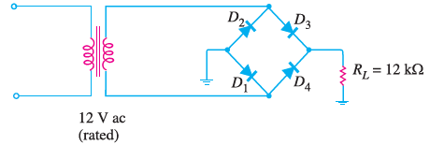

Fig. 6

|  |  |  |
| --- | --- | --- |
| Major Topic  Diodes and Applications of Diodes | Blooms Designation  CR | Score  7 |

1. The current through a 0.1H inductor is i(t)=10t e-5t. Find the voltage across the inductor and energy stored in it.

|  |  |  |
| --- | --- | --- |
| Major Topic  Electronic Circuit | Blooms Designation  EV | Score  7 |

1. Determine the Q point of the transistor circuit shown in Fig. 7.

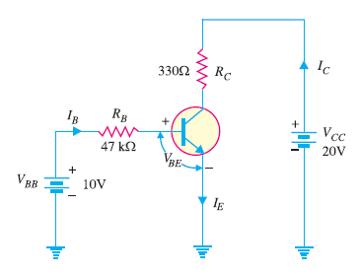

Fig. 7

|  |  |  |
| --- | --- | --- |
| Major Topic  BJ Transistors | Blooms Designation  CR | Score  6 |

d) In your own words briefly explain the term peak inverse voltage in PN in PN Junction diodes

|  |  |  |
| --- | --- | --- |
| Major Topic  PN Junction Diode | Blooms Designation  EV | Score  5 |

**TOTAL SCORE: 25 MARKS**

**Question 10**

a) For the circuit shown in Fig.8, find the output D.C. voltage

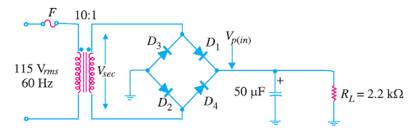

Fig. 8

|  |  |  |
| --- | --- | --- |
| Major Topic  Diodes and Applications of Diodes | Blooms Designation  CR | Score  7 |

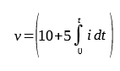

1. Find the power delivered to an element at t=5ms if the current i=5cost60пt A and the voltage

|  |  |  |
| --- | --- | --- |
| Major Topic  Electronic Circuits | Blooms Designation  EV | Score  7 |

### c) Determine VCBin the transistor circuit shown in Fig. 10. The transistor is of silicon and has β = 150.

.

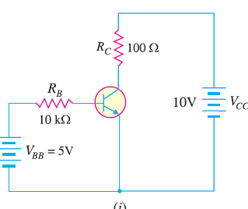

Fig. 10

|  |  |  |
| --- | --- | --- |
| Major Topic  BJT Transistors | Blooms Designation  CR | Score  6 |

1. Explain in your own words the term **doping**. why doping is important.

|  |  |  |
| --- | --- | --- |
| Major Topic  Semiconductor devices | Blooms Designation  EV | Score  5 |

**TOTAL SCORE: 25 MARKS**

**END OF QUESTION PAPER**